HIGHER & INTERMEDIATE 2

BASKETBALL

STRUCTURES & STRATEGIES
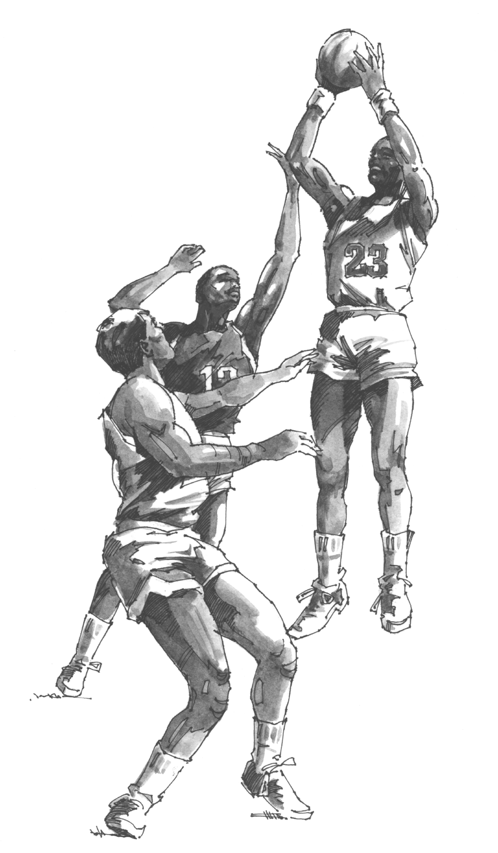

OUTCOMES

1. Record, describe and explain performance.

2. Use Knowledge and Understanding to describe performance.

3. Suggest improvements to performance.

CONTENTS

INTRODUCTION

CHAPTER 1

STRUCTURES & STRATEGIES

BASKETBALL TERMS

BASKETBALL RULES

CHAPTER 2

ROLES & RESPONSIBILITES

CHAPTER 3

OFFENSIVE STRATEGIES

CHAPTER 4

DEFENSIVE STRATEGIES

CHAPTER 5

PRINCIPLES OF PLAY

CHAPTER 6

ADAPTING STRATEGIES

CHAPTER 7

METHODS OF ANALYSIS STRATEGIES

CHAPTER 8

FOOTBALL STRUCTURES AND STRATEGIES

INTRODUCTION

The area of STRUCTURES STRATEGIES AND COMPOSITION looks at the structure of teams, the different formations, and principles of attack and defence. It also looks at how these strategies are applied, to make best use of strengths and weaknesses.

In this unit the KEY CONCEPTS COVERED are as follows

- The Structures, Strategies and Composition that are fundamental to Specific Activities.

- Identification of Strengths and Weaknesses in Performance…
… in terms of Roles and Relationships
… in terms of Formations
… in terms of Group and Team Principles.
… in terms of Tactical and Design Elements.

- Problem Solving and Decision Making within selected Structures, Strategies or Composition.

In this package we will look at specific examples and how they relate to Basketball. The main structures looked at are the Fast Break attack, Man-for-Man and Zone defence,.

We will cover these areas in a practical setting in class time and follow them up with class discussion and homework questions. It is vital that you back up all class work with extension reading, as well as completing the homework on time.
CHAPTER 1

STRUCTURES & STRATEGIES

BASKETBALL TERMS

BASKETBALL RULES

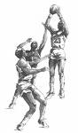
STRUCTURES AND STRATEGIES

A structure is the design, formations and organisations that teams/groups use in different activities. It is the way that the team is set up. For example in basketball setting out to use a 2–3 defence or a 1–3–1 attack or in football using a 443 formation. Structures give a team a shape or pattern and allocate players a position on the pitch/court and a specific role. However the structure must be flexible enough to cope with unpredictable or unplanned events. A good team will be able to play and adapt a number of different formations depending on the opposition, the team tactics and what is happening during the actual game.

A strategy is the management of the tactics and skills of the game. It is a planned system of play, which is implemented during the game to achieve specific outcomes. A feature of an effective team is the application of an appropriate game plan. In terms of strategic planning, a strategy could be defined in two ways. Firstly an immediate next stage within a game context, for example, ‘setting up a zone’ or secondly it can be defined as longer-term planning, such as preparing for a league championship final.

Tactics can be defined as the procedure for applying specific offensive/defensive plans to meet match demands. Tactics involve more than one player and normally makes good use of individual skills. It is important that all the players know the game plan and recognise what to do when the game plan breaks down. Tactical plans are designed to equip players with the ability to solve game problems independent of the coach. The success of a game plan requires good teamwork and application of team skills. Teams should be coached to have a sound awareness of each other’s strengths and weaknesses and practice facing game problems.

Basketball is a fast moving, dynamic game, which constantly presents varied problems and challenges for players. During training sessions players should practice set moves, in order to meet a variety of game demands. The principles of the game of basketball can be divided into offensive (attacking) and defensive principles and are based on the awareness of space, time and action. The ability of players to participate or execute a strategy or tactic will depend on the player’s technical, physical and mental qualities. Finally, when selecting the appropriate strategy the following procedures can be applied and should be examined as a shared team experience.
Diagram 1
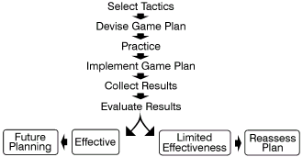

BASKETBALL TERMS

Boards or off the boards- a rebound

Corner-the area directly to either side of the basket near the baseline. You cannot use the backboard for corner shots.

Discontinuing-a dribbling violation; dribbling for a second time after stopping.

Double dribble-a dribbling violation; dribbling with 2 hands.

Forecourt and backcourt are not on the court. These are not specific locations. The forecourt is where the forwards play on offense. It is fore or closer to the basket than where the guards play. In a full court press when the guards take the ball out from the baseline, the forecourt could be near mid court. In a regular offense the forecourt is around the basket and baseline. Farther away from the basket or back are the guards in the backcourt.

Foul line extended-walk on the foul line toward the left or right sideline. This area or line you walk on outside the foul line is the foul line extended area. With a paint brush you could extend the foul line to the sidelines. These extensions on the left and right sides are considered the foul line extended.

Free throw line-foul line

Give and go- Passing, then cutting to the basket (or other area) expecting to receive a return pass.

Head-to head or belly-to-belly-play tight one-on-one defence.

Help out-moving into position to cover and covering another player's offensive assignment.

Inside-closer to the basket, usually in the lane. The defence usually takes an inside position. The offense always wants to pass inside.

In-in bounds; inside.

Man-to-man- term for person-to-person defensive coverage.

On-off ball-On ball refers to defensive coverage on the ball. Off ball is the coverage on the other 4 players without the ball. On ball coverage is usually tight, whereas off ball coverage is usually much looser.

One-on-one-person-to-person defensive coverage.

Outside-farther from the basket. Teams do not want to take too many outside shots. Shorter players usually play outside.

Out-out-of-bounds; outside.

Over and back- game violation; when you cross half court with the ball and then go back.

Paint-the 3 second lane. On most professional courts it is painted one colour.

Palming-a dribbling violation when the palm of the dribbling hand is turned upward (and then downward) to better control the ball.

Ready position- a player's body position when on the court. The body should be in a half down position, feet shoulder width apart. Body weight is on the balls of the feet. Bending is from the knees, not the back. The fingers are spread apart clawed. The ready positions for rebounding, defence, and offense are similar.

Screen or pick-when a stationary offensive player is used as, or sets up as, a block or impediment on the defensive player assigned to another offensive player. It is a violation if the screen moves to cause contact with the defence.

Shooting range or range-the maximum distance from which you can shoot well. Players often shoot from beyond their range.

Slough off-the defence moves away from the offense toward the basket.

Strong- weak-side-The ball side of the court is called the strong side. The defence needs to guard closely here. The weak side is the off ball side of the court. The defence can slough off individual coverage and move toward the lane to help out.

The Lane-the 3 second lane.

Three second lane-the lane: the paint.

Tied up-when the offense is not able to pass or move the ball because the defence either gets their hands on the ball (jump ball) or prevents ball movement for 5 seconds (a violation).

Transition or transition game- moving from offense to defence or vice-versa. Players need to make quick transitions, especially from offense to defence.

Travelling-see "walking" below.

Violation-against the rules. The other team is awarded theball out-of-bounds.

Walking-travelling; sliding the pivot foot while holding the ball or taking more than one-and-a-half steps while holding the ball. The half step is actually another step. Another way to say this is that it is a violation to take 2 full steps with the ball. When catching, a player takes the half step first. When passing or dribbling, the half step is the second step.
BASKETBALL RULES

VIOLATIONS

Travelling, double dribble, holding the ball longer than 5 secs, stopping the ball on its downward path into the basket, kicking the ball, punching the ball, passing the ball back over the centre and breaking any time limits.
After a violation the opposing team is given the ball on the sideline to throw into play at the point nearest to where the violation happened.
Held ball when two players from opposite teams both end up holding the ball the referee will restart the game with a jump ball between the two players at the nearest circle

PERSONAL FOULS

Pushing, pulling, bumping, holding, tripping or charging an opponent is deemed a personal foul. After a personal foul the player's number is noted at the scorer's table and a foul is noted against the player's name on the score sheet. A player who commits 5 personal fouls is fouled out of the game and can take no further part in the game.

The referee will award a side ball to the opposition HOWEVER

If a player is fouled in the act of shooting and the basket is scored, then the points will stand and the player will get one free throw. If the foul stops a score being made then two or three free throws will be awarded depending on whether it was a two or three point shot.
Every free throw is taken from the free throw line and is worth one point. A player has five seconds to take each free throw. When the free throw is being taken none of the other players can go into the free throw area.

TEAM FOULS

Every personal foul that is committed counts towards the total of the team fouls. After a team has reached 7 team fouls every foul after that results in free throws

TECHNICAL FOULS

Technical fouls are called against players and teams for delaying the game and unfair conduct i.e. Illegal substitutions or illegal time-outs.
Free throws can be awarded after technical fouls on a one and one basis. This is where the team are awarded 1 free throw and if it is scored they are awarded 1 more. Depending on the type of foul the referee may also award the team possession from the halfway line.

TIME LIMITS

5 sec's .Any player cannot hold onto the ball longer than 5 sec's before they have to pass dribble or shoot. 24 sec's. Once a team has the ball they must make a shot at the basket within 30 sec's. 8 sec's A team has 8 sec's to move the ball over the centre line into the attacking halt: 3 sec's .No player from the attacking team can stay in the key area for more than 3 sec's without the ball.

CHAPTER 2

ROLES & RESPONSIBILITIES

KEY CONCEPT: Identification of Strengths and Weaknesses in Performance in terms of Roles and Relationships.

Roles & Responsibilities

In most team games, different players within the team have different roles to play. Some players are very specialised and have very different tasks to the other players (ie. goalkeeper in Football.) There will be different demands on different positions in terms of skills, physical and personal qualities.

Each player on a basketball team has a position to play. It is related to role, ability and skill. The three basic positions in basketball are guard, forward and centre (or post). The centre is usually the tallest player, with forwards next and guards being the smallest. Centres and forwards tend to be the best rebounders, while guards are often the best ball handlers. Guards also tend to play outside more than forwards and centres.

ORDER OF IMPORTANCE | GUARDS | FORWARDS | CENTRES
1 | DRIBBLING | SHOOTING | REBOUNDING
2 | PASSING | REBOUNDING | SHOOTING
3 | SHOOTING | PASSING | PASSING
4 | REBOUNDING | DRIBBLING | DRIBBLING

The following three pages describe each position in more detail, describing both their responsibilities in defence and offence.

Guards (Shooting & Point)

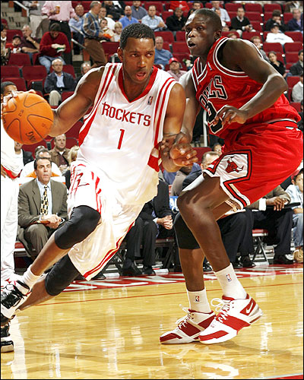

Guards by the nature of their position will do a lot of ball handling. Any defensive pressure will be first applied to them. Guards need qualities of vision and quickness above all and extra skills in passing and dribbling. Guards also tend to be the shorter and quicker player s in the team.

Guards are usually called the team’s backcourt when grouped together. This grouping can be broken down further into point guards (normally the best ball handler and often the player who directs the team on the floor) and shooting guards (also called “big” guards).

Because of their dribbling ability point guards are often able to create a scoring chance for a team-mate by penetrating and passing, that is, by driving past defenders to the basket and passing to an open or unguarded team-mate. Point guards are called playmakers because they direct teammates and create scoring opportunities. The point guard will usually be among the best ball handlers on your team and should also be a leader who can be the coach on the floor.

Choose shooting guards from among the best shooters and ball handlers on your team. Confident shooting is another important characteristic to look for in a shooting guard.

Offensive Qualities  • Guards shoot from outside more than inside the key and must be good at taking a pass from a forward in a give and go situation.  • Guards must learn to penetrate the key with the dribble to draw the defence out of position.  • Guards use fakes to get free more and have room to work.  • Guards lead the fast break and must constantly look for the outlet pass. | Defensive Qualities  • Guards play all-court defence and must be the last line against a fast breaking team and the first as the ball is moved up court as the break is contained.  • Since they play in space they must contain dribblers by effective defensive shuffling and lateral movement.  • In transition from offence to defence, guards carry the main responsibility – quickness of thought and speed of reaction are important.

Forwards

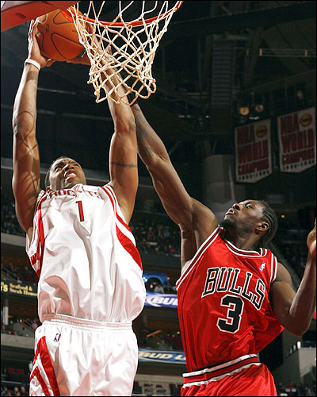

A good forward, whether in offence or defence, needs all round skills more than any other position. His rebound responsibilities are heavy. Forwards are sometimes called corner players because their normal offensive position is in the corner of the frontcourt. Small forwards should be able to play as a combination guard forward, handle the ball well, play outside on the perimeter and rebound. Big forwards must be combination forward-centres.

Offensive Qualities  • Forwards shoot most often from the side court position, usually under pressure.  • Forwards look to move into holes in defence, attacking the basket particularly against zone defences.  • Forwards look to set screens for guards against man to man defences.  • Forwards run the outside lanes in the fast break, when the shot is made from the other end of the court. | Defensive Qualities  • Forwards help out defensively against the opposition centre.  • Forwards need to get into good rebounding positions.  • Forwards need to be good exponents of the outlet pass to start the fast break, but also need to use the power dribble to come away from the basket.  • Forwards are usually the first lines of defence against the fast break and must try to smother the outlet pass. If not in a position to do that, they must get back quickly.

Centres

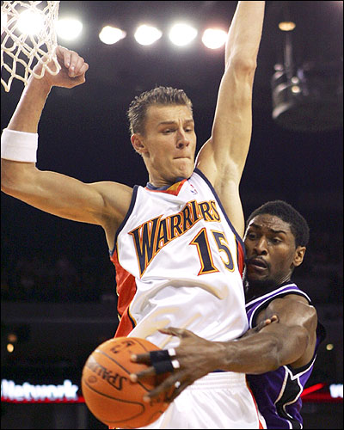

Choose players for the centre position from among your biggest players who relish playing inside, near the basket, where contact and congestion are readily accepted. The centre is usually the biggest player and plays inside around the free throw lane area in the high post (near the foul line) or in the low post (close to the basket) and outside the free throw or three second lane with his or her back to the basket. The centre and two forwards are collectively known as the frontcourt.

Offensive Qualities  • Centres are the fulcrum of attack and must learn to get open and hold position generally in the middle of the key.  • Centres receive high balls from forwards and guards and must learn to cut into the key area, receive and shoot.  • Centres will shoot from short distances and learn to use shots off the backboard and to fake before shots.  • Centres support the fast break by coming down in the second wave of attack to receive the ball from a guard at the top of the key or from a forward on the side. | Defensive Qualities  • Centres are the last line of defence if guards or forwards are beaten. They look to help out and take a defensive line between the ball and the basket.  • Centres take the major rebounding responsibility and must work not only to block out their immediate opponent but also to take all rebounds.  • Centres have the farthest to go against a fast break and their recovery and transition rate must be high. The physical demands are often extreme. They must take their opportunities to rest in offensive situations.

Name of role and number associated with plays | Where player is positioned on the court | Role | Qualities Possessed | Order of Responsibility
GUARD - 1 | - Perimeter/ “point” player | - ATTACK  - Play maker/ Coach on court  - Communicates what plays to be performed  - Initiates plays  - DEFENCE  - Matches up with opposing guard  - Aims to force them to the sides of the court away from danger area | - Usually smallest player in the team  - Good ball handling skills  - Good communication skills  - Peripheral vision | - Dribbling  - Passing  - Shooting  - Rebounding
FORWARD – 2+3 | - Plays within the 3 pt area | - OFFENCE  - Main outlet option for fast break  - Good at transition (changing from defence to offence)  - DEFENCE  - Picks up other forwards  - Helps inside the key  - Alerts guard to dangers e.g. screens etc. | - Usually best shooter  - Fast  - Very effective in 1v1 situations | - Shooting  - Rebounding  - Dribbling  - Passing
CENTRE  - 4 + 5 | - Plays inside the “key” | - OFFENCE  - Main rebounder in the team  - Plays on the “posts”  - Very effective close in to the basket  - DEFENCE  - Matches up with opposing centre  - Usually in help side under the basket  - Stops drives to the basket | - Tallest player  - Strong/ Tough at the boards  - Effective post player  - Good spatial awareness for cutting in and out of the key | - Rebounding  - Shooting  - Passing  - Dribbling

CHAPTER 3

OFFENSIVE STRATEGIES

KEY CONCEPT : Identification of Strengths and Weaknesses in Performance in terms of Formations and in terms of Tactical and design elements.

General Offensive Principles

Unless you are very familiar with the offensive strengths and weaknesses of team members, you should select a basic offence that can be adapted to a variety of players. It should be flexible enough to allow team members to use their individual strengths.

Any offence should have court balance, that is, it should produce high percentage shots with assigned offensive rebounders and assigned players for defence when a shot is taken. Balance also refers to maintaining proper court spacing – about 15 to 18ft apart – between offensive team-mates. Balanced scoring from players is always better than dependence on a scoring star.

A good offence includes player movement as well as ball movement. Scoring should come from the inside (close to the basket) as well as the outside (on the perimeter of the defence). This prevents the defence from concentrating on one area or one player. The execution of any system you design is much more important than the system itself. What your team does is not so critical as how well they do it.

Offensive Team Tactics

Develop team tactics to prepare your team to face all basic defensive situations. You will need to include:
- A fast break offence to keep the defence honest and put immediate pressure on the opponents
- A set offence for situations where opponents guard your players individually (man to man)
- A zone set offence to be used against zone or area defences

Set Offence

If the defence is set and waiting a set offence should be used to get a good shot. Your team should get into a basic starting formation and then use the fundamental skill moves with and without the ball to create scoring opportunities.

This basic set or formation may take a variety of starting positions. You should select a preferred starting formation that fits your personnel and favoured tactics. The 1-2-2 “Give-and-Go”

One offence for beginning players is the 1-2-2 give-and-go offence. It can be used effectively against player-to-player defences. The give-and-go offence is a simple team offence that utilises passing, catching, basic moves without the ball and individual moves with the ball. The 1-2-2 double low post or open post set is a one-guard, open post formation that allows any player to V-cut into the post area and keeps the middle open for individual offensive moves plus give-and-go options. The give-and-go offence from the 1-2-2 open post formation can also be used against zone or combination (zone and player-to-player) defences by depending less on cutting and emphasising more individual moves from stationary spots.

Fast Break

One way the team can set up good shot is to run the fast break where the team that gains ball possession brings the ball up the court before opponents can get into good defensive position. The fast break usually develops after a rebound, steal or possibly after a made basket, and is the fastest way to make the transition from defence to offence. As soon as the defence gains control of the ball they use the outlet pass or dribble to start the break – passing being the first option and dribbling the last when moving the ball up the court. Then the other team-mates attempt to beat the defenders up the court while staying spread out. Players should run at top speed under control when fast-breaking up the court. Remember to have one player stay a few steps behind the action in a defensive safety role for balance.

Diagram 2

THE FAST BREAK

The fast break should be the first attacking tactic that a team should try to run. As soon as a team gain possession they should try to initiate the fast break, as it is the best way to create an easy scoring opportunity.

The fast break begins when the defending team gain possession of the ball. This can be from a steal, an interception, a rebound and even sideline balls or scored baskets if the team is organised enough. Although a fast break can start from many different situations the main one tends to be rebounds from missed shots.

Each fast break follows the same general principles: regain possession, fast delivery of the ball up to the opponents basket, attackers outnumber defenders, players give options around the basket all leading to an uncontested lay up or shot.

Within the fast break each member of the team has a role to fulfil in order for the fast break to be effective and run smoothly.

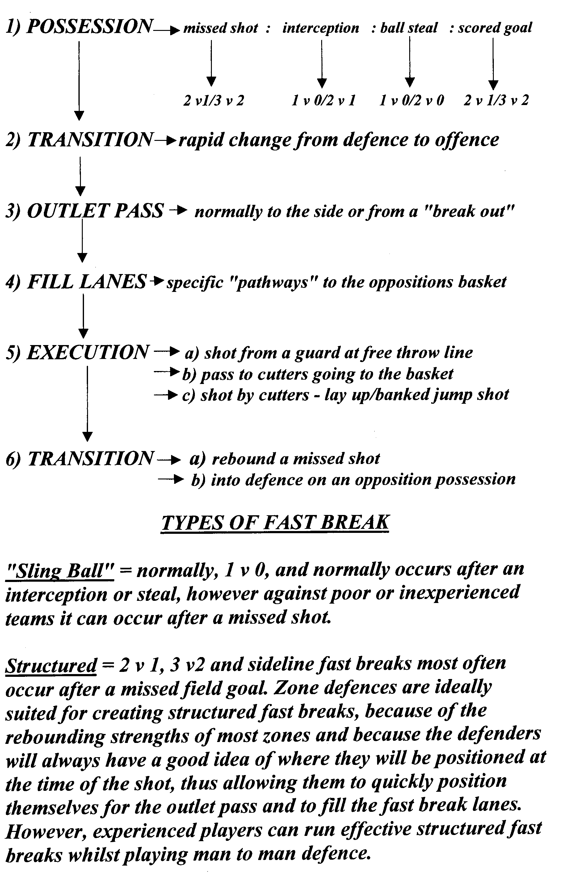
3 PERSON FAST BREAK

The following is a description of a simple fast break involving 3 players see diagram3 on next page.

The attacking team have pushed up the court and made an unsuccessful shot at the basket. The centre (X1) rebounds the ball and pivots to the open side, the centre then looks up, to make an outlet pass to the guard (X2). The outlet pass should be on the same side of the court as the rebound this should ensure that the ball is taken away from the clutter of bodies in the key. The outlet pass provides initial width in the attack this creates space to allow the guard to operate. The centre should try not to make an outlet pass across the key as this could be intercepted secondly they should only play the pass when the guard communicates that they want the ball and the pass should only be made if the guard is free. If the guard is marked tightly the centre can dribble the ball forward. Therefore we see that decision making on the part of the centre is vital.

When the centre (X1) has gained possession of the ball from the rebound the guard (X2) moves into the wide right lane to receive the outlet pass. They should communicate when they want the pass by shouting ‘ball’ this lets the centre know when to release the pass but it also communicates to the rest of the team that the fast break is on. This communication is vital as everybody in the team needs to know what is happening so they can assume their role in the tactic. Without good communication there can be uncertainty which causes hesitation and the fast break will be slowed down which means it will probably be unsuccessful as the tactic relies on speed of thought and action.

Once the guard has received the ball they ‘dribble to the middle’ lane at pace. By going down the middle that means that options are opened up down both sides of the court. As soon as the centre has made the outlet pass they sprint as fast as they can to fill the wide right lane and get ahead of the ball as fast as is possible. At the same time the forward (X3) sprints as fast as they can to fill the wide left lane and get ahead of the ball as fast as is possible. By ‘filling the lanes’ the centre and forward are providing width in attack. This creates space by spreading out the defenders who manage to get back causing gaps. This also provides the guard with passing options on both the left and the right. It is important that the forward and the centre get ahead of the guard to create depth in the attack by moving up quickly they are able to penetrate the defence and create overload situations where the attack outnumber the defence.

The guard continues to dibble at pace until they reach the top of the key, the guard should arrive at the top of the key as the centre and forward reach the extended free throw line. When the centre and forward reach the extended free throw line they cut towards the basket looking for a pass from the guard to go in for an uncontested lay up. The player who does not receive the ball should continue towards the basket to provide an attacking rebound option if the shot is missed.

When the guard reaches the top of the key decision-making is vital. The first option should be to pass the ball to the cutting centre if they are unmarked for an uncontested lay up; the second is to pass to the cutting forward, the third is to drive towards the basket themselves for a lay up The fourth is a jump shot from the free throw line. If the guard selects the option to pass to either the centre or the forward then they must remain at the top of the key to receive a pass back or if the centre or forward makes a shot the guard must offer a rebound option.

Diagram 3
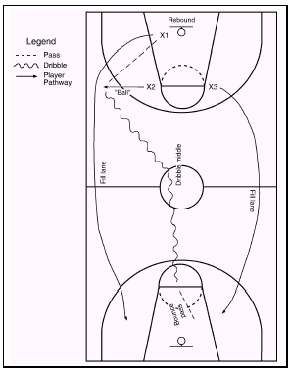
Extended free throw line (imaginary line)

It is important that the fast break is flexible and as such there are many variations. From the simple “sling ball” when a team gain possession 1 player gets free up the court behind the defence and receives a long pass for an uncontested lay up, to the more complex set patterns as described above. Diagrams 4-6 show some variations on the set fast break above that can be used as alternatives depending on what the defence do.
Diagram 4 is a variation on Diagram 3. This time player X3 receives the ball earlier and passes to player X1 who was the original rebounder. Speed is vital. Player X3 must sprint ahead and fill the lane. Player X2 is likely to dribble the ball down the middle and pass on to player X3. This is called Option A.

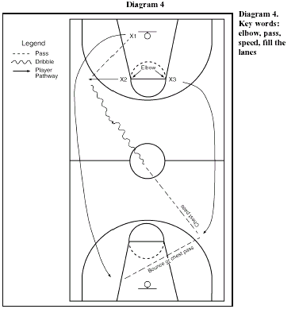

Diagram 4: Key Points
- Player X3 passes the ball because a defender may have got back and be actively defending against player X3. Player X1 may be unopposed. By passing onto this player they can drive in easily and score a basket.

- By ensuring that player X1 keeps going other options may come into play such as an attacking rebound. Ensuring that player X1 continues to fill their lane is important for the overall balance of the fast-break.

Diagram 5 is a variation of diagram 4. It is called Option B. In this drill player X1 rebounds and passes to player X2. This player dribbles the middle and passes to player X3. This time player X3 cannot get a pass away to player X1. This is because the (imaginary) defenders have stayed closer to the basket and have not committed themselves to moving out towards player X3. This time player X3 fakes a pass to X1 and reverse-passes to player X2 at the free throw line, who then shoots. It is for this reason that player X2 must stay out of the key in earlier drills. Players X1 and X3 look to rebound the shot and score from any rebound.

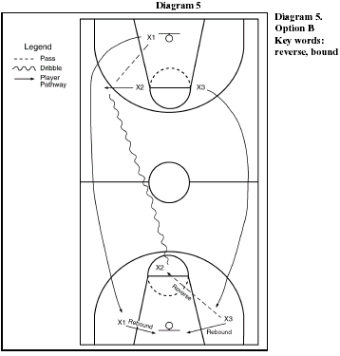
Diagram 6 is a variation of diagram 5. It is called Option C. In this drill the (imaginary) defender comes out to mark player X2. As a result player X2 fakes to shoot and then passes the ball to X1 who should be moving towards the basket for an unopposed lay-up shot.

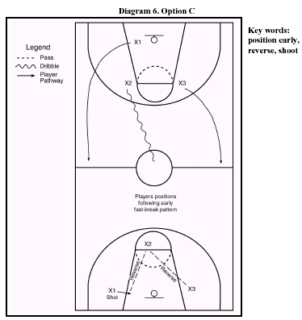

Diagram 4 – 6: key points (practice variation – introduction of a defender 3v1)

The drills on Diagram 4 –6 can be repeated against a defender for Options A, B & C. The key point to stress is that it is the actions of the defender that allow the attackers to make decisions about their course of action. The task for the attackers is to take an uncontested lay-up attempt on the basket, as this is the highest percentage chance the attackers will have to score a basket.
DEVELOPING THE FASTBREAK

The following explanations and diagrams are a number of drills to develop the fast break.

1. Rebound and outlet pass

First, to get the break going, you must box-out, get the defensive rebound and the quick outlet pass.

Box Out-Rebound-Outlet Pass.
A good rebounder first locates his/her man, gets inside position, pivots to face the basket, and boxes-out. Get wide with arms and feet out and be strong with your butt back into the opponent. Don't get too far under the basket. Jump and grab the rebound securely. Land, pivot to the sideline and make the hard two-handed overhead outlet pass to start the fast-break.

2. Outlet to Wing Drill
Have two offensive and defensive re-bounders near the basket. If you are teaching the outlet pass to the wing, have a guard on each wing (free-throw line extended). The coach shoots the ball up and the re-bounders fight for position and get the rebound. If the offense gets the ball, they return it to the coach for another shot. When the defender gets the rebound, he/she pivots immediately on the outside foot toward the sideline, wheels and throws the two-handed overhead pass to the wing. Repeat this over and over, to both sides. From time to time, have another player, manager or assistant step into the outlet passing lane, so that the re-bounder learns to look first for his receiver, before blindly making a bad pass.

3. Filling Lanes.
In 3s passing down court. The ball always travels through the middle and players stay in lane. No opposition. At free throw line middle player lays the ball to one of the side players to score.

4. 2 v 1
In half court against a passive defender, draw defender and pass, or drive straight to the basket.

5. 3-on-2 Break
As practice 3 but with 2 defenders in the key.

In this situation, there are two defenders back and the offence has the middle and two outside lanes filled. Usually, one defender will stop the ball at the top, and one stays inside down low. Player 1 in attack should not penetrate beyond the free-throw line. He/she should look for player 2 or 3 cutting toward the hoop and make the pass to the open wing, who then has a 2-on-1 situation with the low defender and should look to score or get fouled as the first option (Diagram A below). Over-passing on the move sometimes results in a turnover and a missed opportunity. If the defender sets to take the charge, pass either to the team-mate on the opposite block (3), or back to player 1 for the easy shot from the elbow (Diagram B).

(Diagram B)
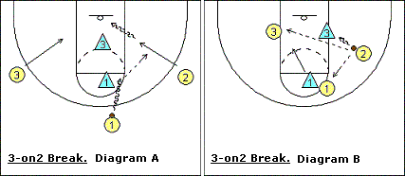

6. Conditioned game using fast break attacks.

Diagram 7 is a 3-attackers versus 2-defenders practice. The attackers follow the same pattern as before. When player X2 arrives at the free throw line he/she must try to commit the last defender. He/she needs to keep their dribble going. If they do this and the second defender stays near the basket they can pass to player X1 or X3.

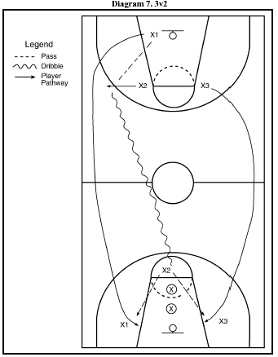

Diagram 7: key points (practice variation – introduction of a second defender 3v2)

This drill is a good way to build up the fast-break offence. If dribbler X2 commits the first defender, this will take this player out of the play. When the pass is made to either X1 or X3, it has now become a 2v1. It is very important that player X2 is able to look at the reaction of the second defender. You can often see if they are favoring one side or the other. If they move closer to player X1 then the pass would go to X3 and vice versa.

Diagram 8:
Diagram 8 is a 3-attackers versus 2-defenders practice. The attackers run the fast break, X2 dribbling towards the key and looking at the second, (rear) defender. If the ball is passed to X3 and defenders split and move to mark X1 and X3 respectively then the ball would be reverse-passed back to player X2, who would either shoot from about the free throw line or continue driving in towards the basket.

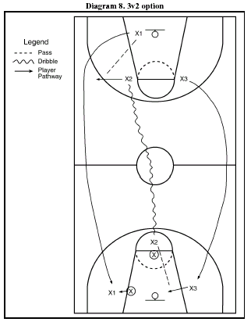

Diagram 9:
In diagram 9, the three offensive players run the same pattern for early offence, i.e., rebound, outlet pass etc. The two defenders start at the half-way line. When the ball is rebounded they must run and place their feet in the centre circle and then begin defending.

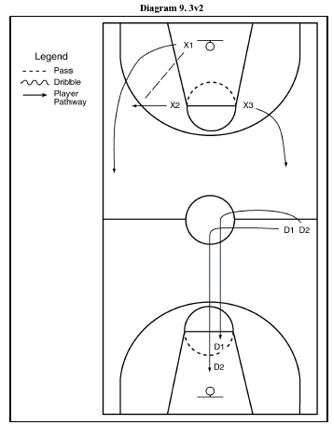

Diagram 9: key points
If the attackers can move the ball very quickly then they may be able to make a scoring attempt before the defenders can get back in place. This can help to make the practice more game-like.
Diagram 10:
In Diagram 10, a third defender is added. However, this defender must not enter the court until the ball has crossed the halfway line. When this happens he/she must also place both their feet in the centre circle before joining teammates D1 & D2.

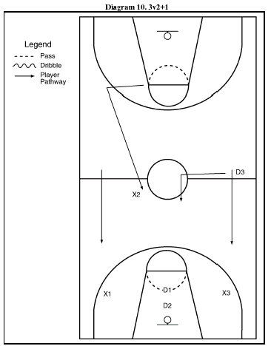

Diagram 10: key points

This practice again puts pressure on the attackers to move the ball very quickly with the defenders running from behind to try and catch up. If the third defender (D3) recovers before the shot is taken then the fast-break opportunity will have been lost. The attacking team can be limited to only make a few passes – e.g. maximum four.
Diagram 11
When the defenders gain possession of the ball in Diagram 11, they become the new attackers. The attacker who last touched the ball before possession was lost becomes the defender. The other two players on offence remain at the basket they have just attacked to become the next defenders.

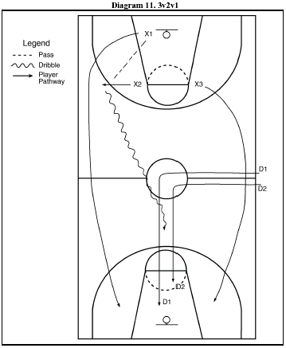

Diagram 11: key points

As soon as the defenders gain possession from an interception, rebound or a successful or unsuccessful shot, they must immediately look too fast-break before the other team can get a player back.
Diagram 12:
In diagram 12, defender D1 has gained possession and has made an outlet pass to D2. X1, who last touched the ball, is trying to get back.

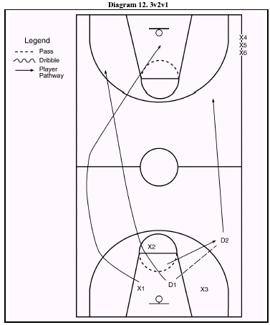

Diagram 12: key points

This movement is known as a transition in Basketball, as it involves a team going from offence to defence and vice versa. It is also a good drill to develop reaction when changing from one to the other and simulates game-like conditions. Players X4, X5 and X6 are waiting at the side of court. They will be the next team on offence. X2 and X3 will become the new D1 and D2. If the offence team score, the defence must inbound the ball before they can resume.

Key =

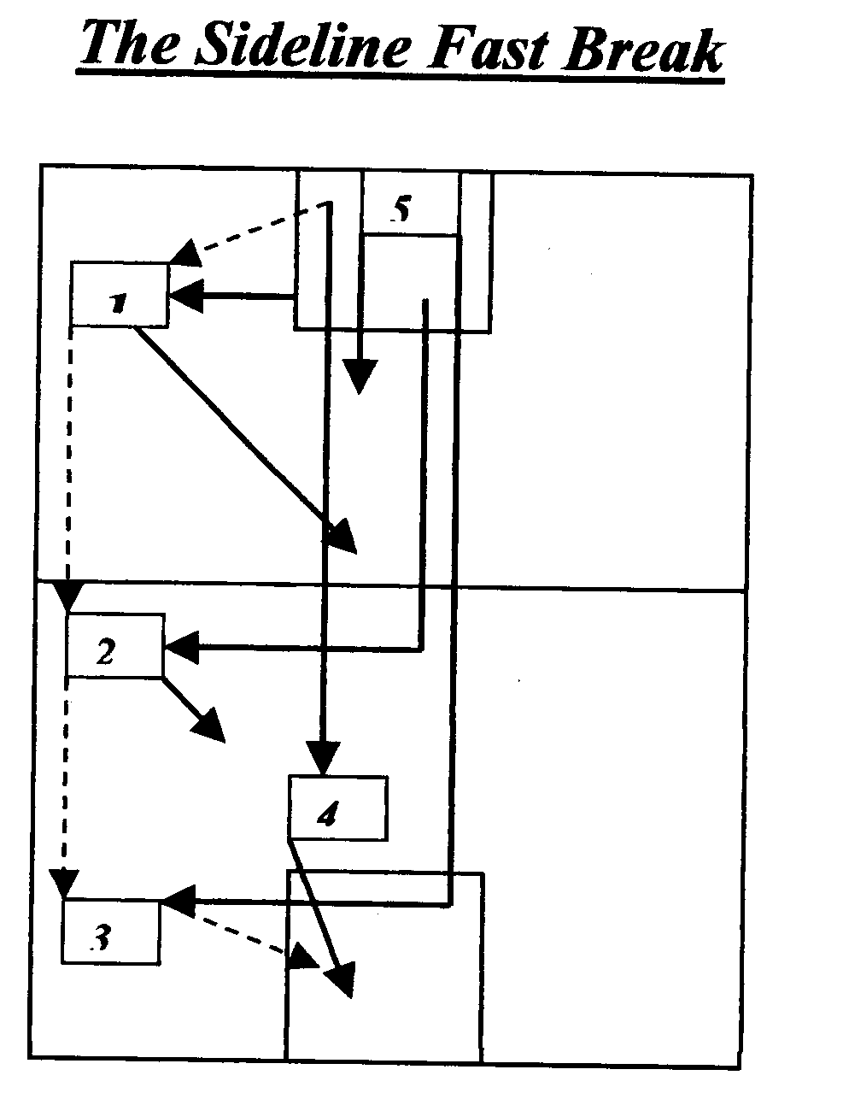

On anticipation of player 4 winning the rebound the three players furthest away from the basket call out the passing areas. The player who calls "1" heads to the side to receive the outlet pass; the player who calls "2" sprints down the centre channel (The Glory Trail) and at a point either side of the halfway line and breaks sharply to the side to receive the pass from the 1 spot; the player who calls "3" sprints down The Glory Trail and at a point around the free throw line the player breaks sharply to the sideline to receive a pass from the 2 spot Upon receiving the pass the players must square up by pivoting towards the sideline in order to protect the ball After passing the ball the players from spots 1 and 2 rejoin the sprint down the Glory Trail to take up key rebounding spots at either side of the basket Having won the initial rebound player 4 sprints down The Glory Trail as the rebounder is the player who completes this exciting form of the fast break by scoring a lay up from a pass from the 3 spot The 5th player trails the attack in the safety position to cover a counter break.

The ball is channelled down the side because that is where the space is, however by the time the ball has reached the 3 spot the defence is being dragged to the side clearing space in The Glory Trail for player 4 who normally has an unchallenged 1 v 0 lay up. What makes this break exciting is that it is fast because the ball never touches the floor, and it is a real team effort as there are four players involved in the attack.

It is important that we develop a range of fast break options, as the fast break has to be continually adapted due to the nature of the game of basketball. Depending on what the defence do or don’t do each fast break situation will be different, as the defence will have set a different problem for us to overcome. This will require a different fast break solution.

ALTERNATIVES TO A FAST BREAK

If the fast break is not on or it breaks down or the defence are back in position then an alternative offence/attack has to be run.

The main offensive aim in basketball is to get to your attacking basket before the defence is set, therefore you are trying to gain numerical advantage. Through trying to engage in this fast type of offence it would result in various scoring opportunities.

Hence your first option is to fast break, but what happens if your transition from defence to offence is not fast enough or if it breaks down?

As an alternative you can employ the 1v1 perimeter moves outlined below. The following strategies should only be used against a man-to-man defence, if you receive the ball in space and time and you are in shooting range (approximately at the edge of the 3 point line or closer). If the defence run a zone defence you can run the motion offence outlined on page 34.

JAB STEP DRIVE

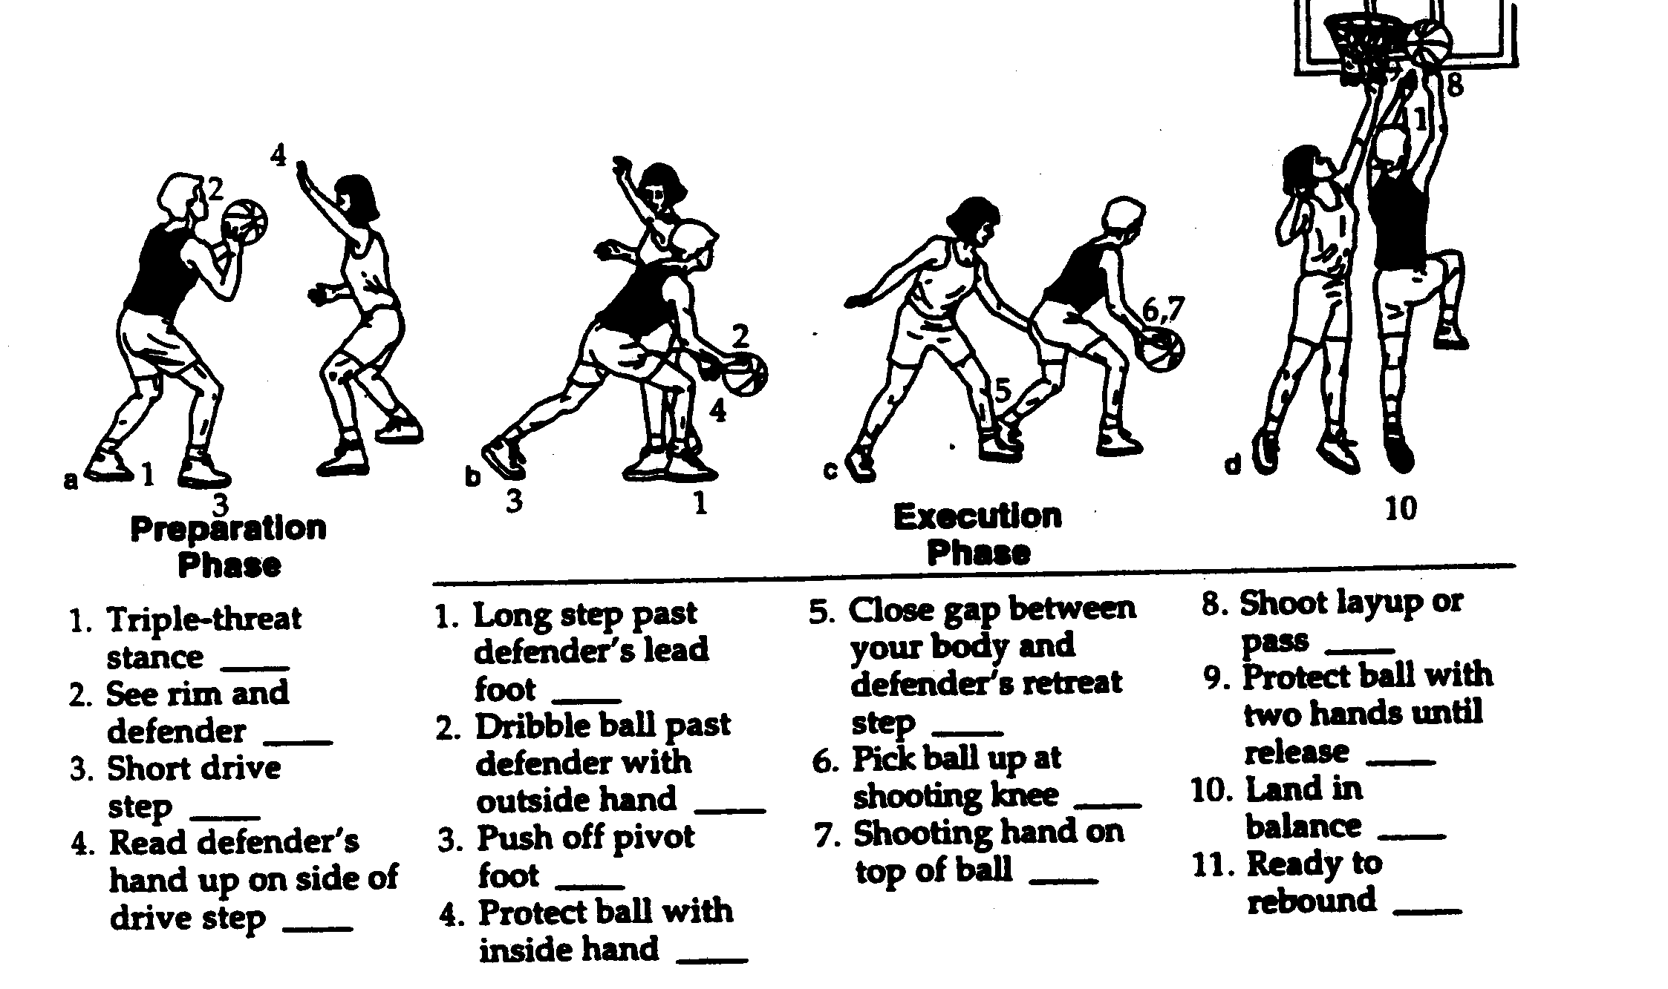

JAB STEP, 1 BOUNCE DRIVE, JUMP SHOT

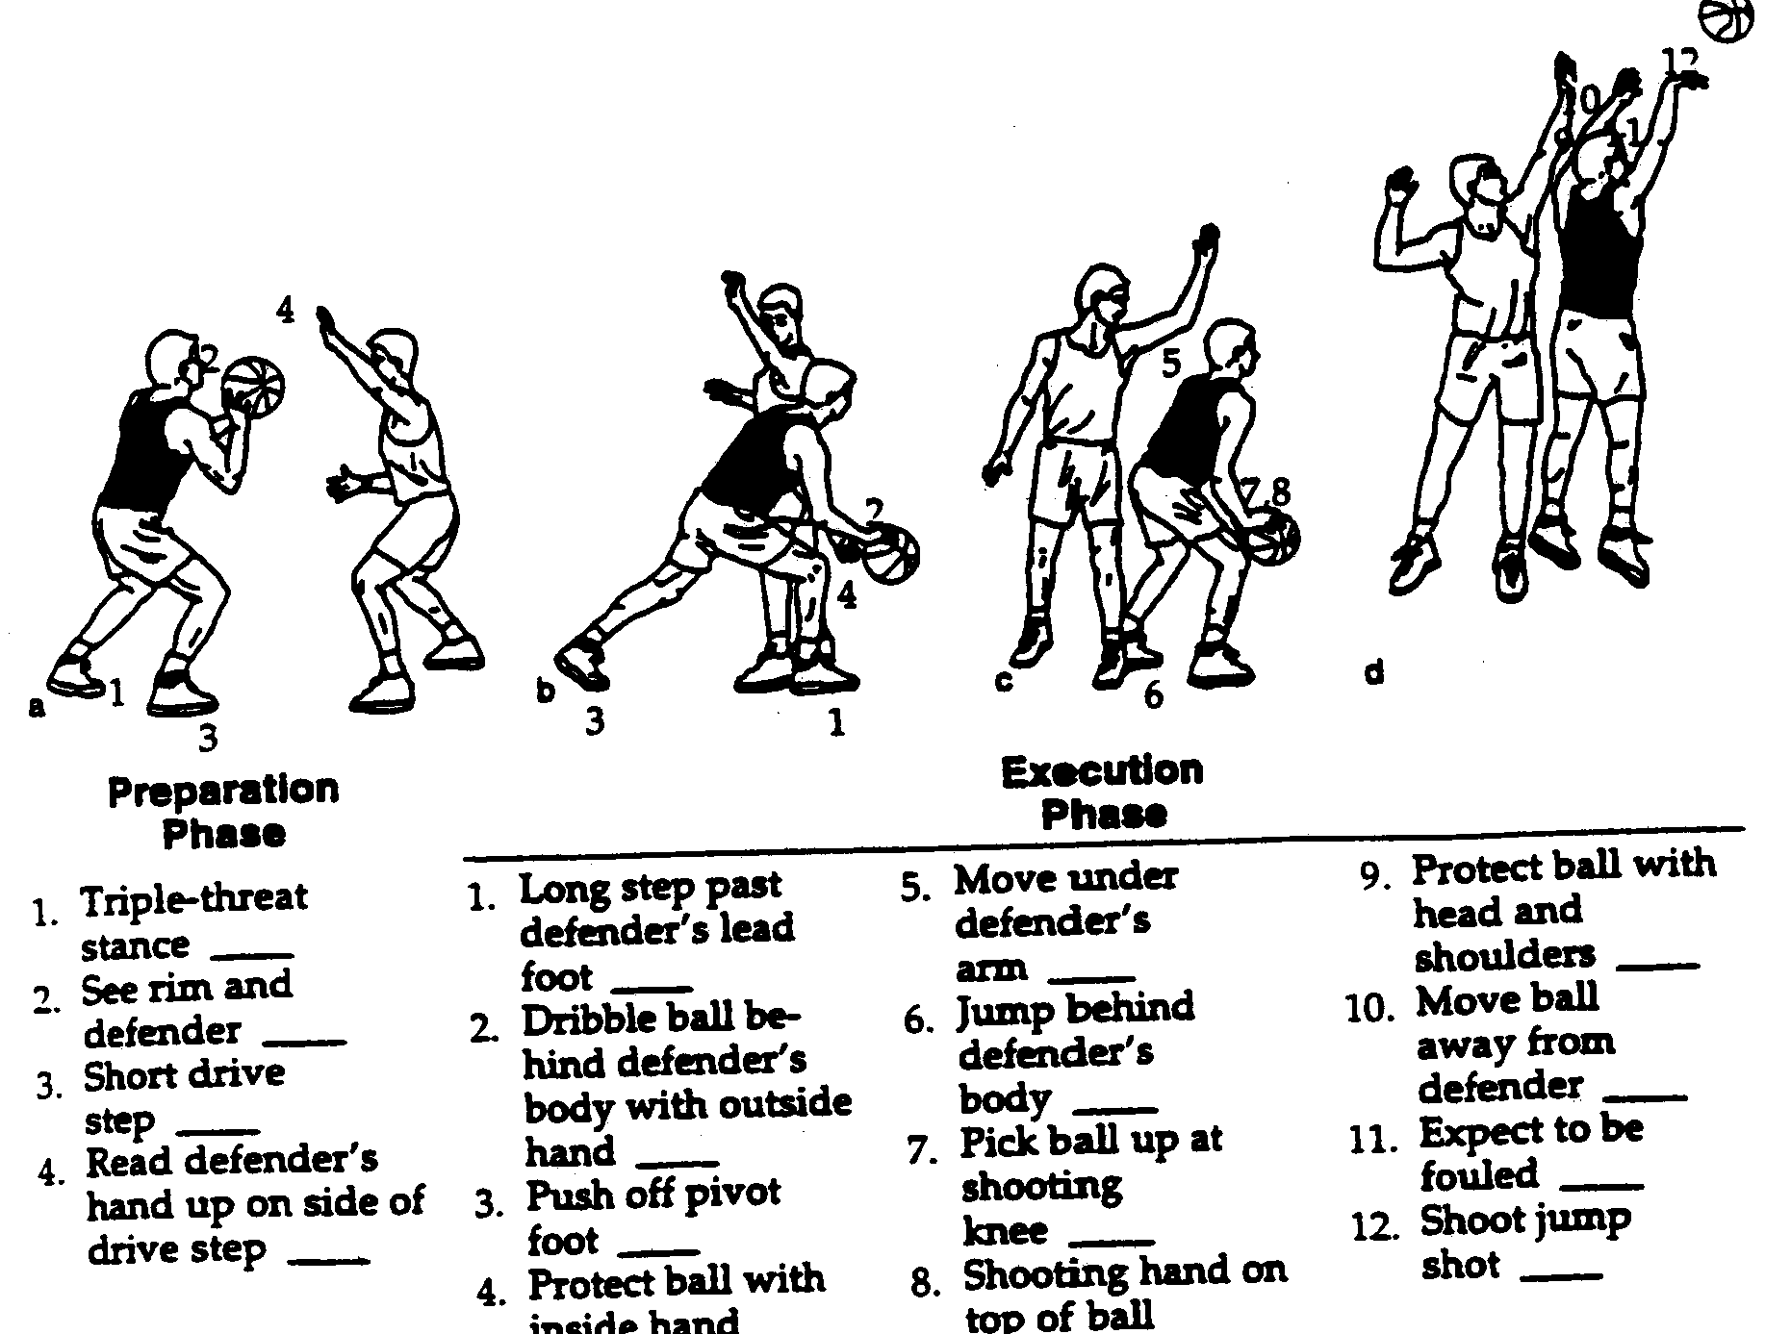

JAB STEP CROSSOVER DRIVE
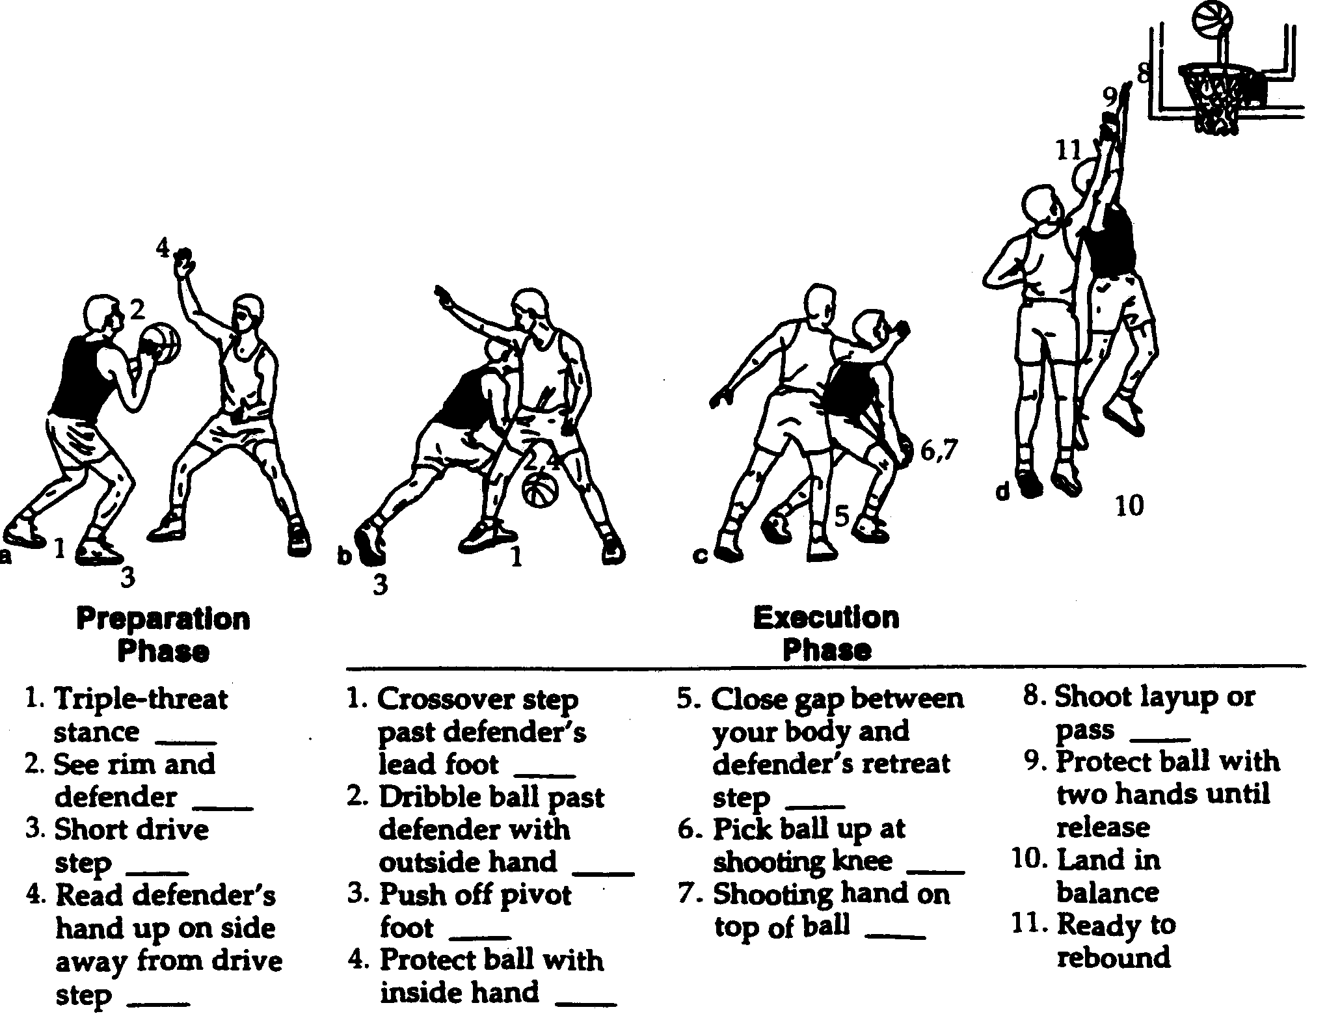

JAB STEP, CROSSOVER DRIVE 1 BOUNCE JUMP SHOT

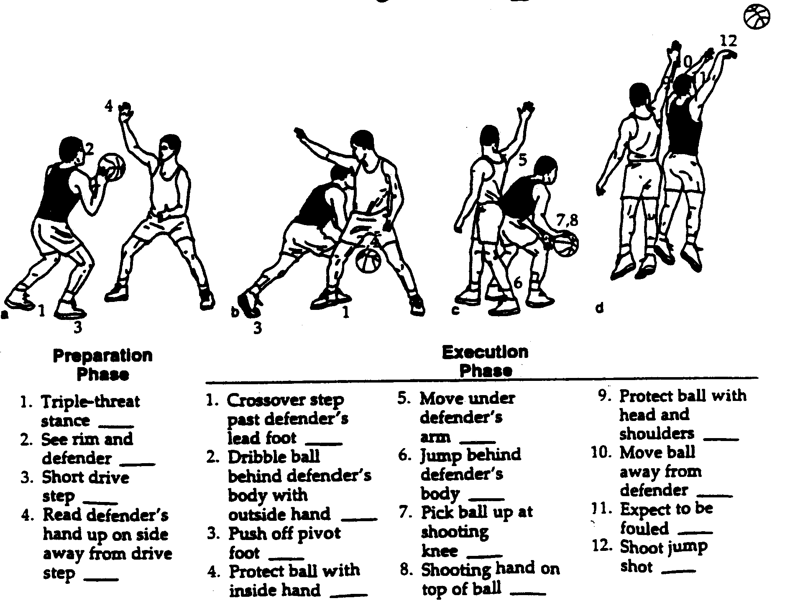

JAB STEP JUMP SHOT

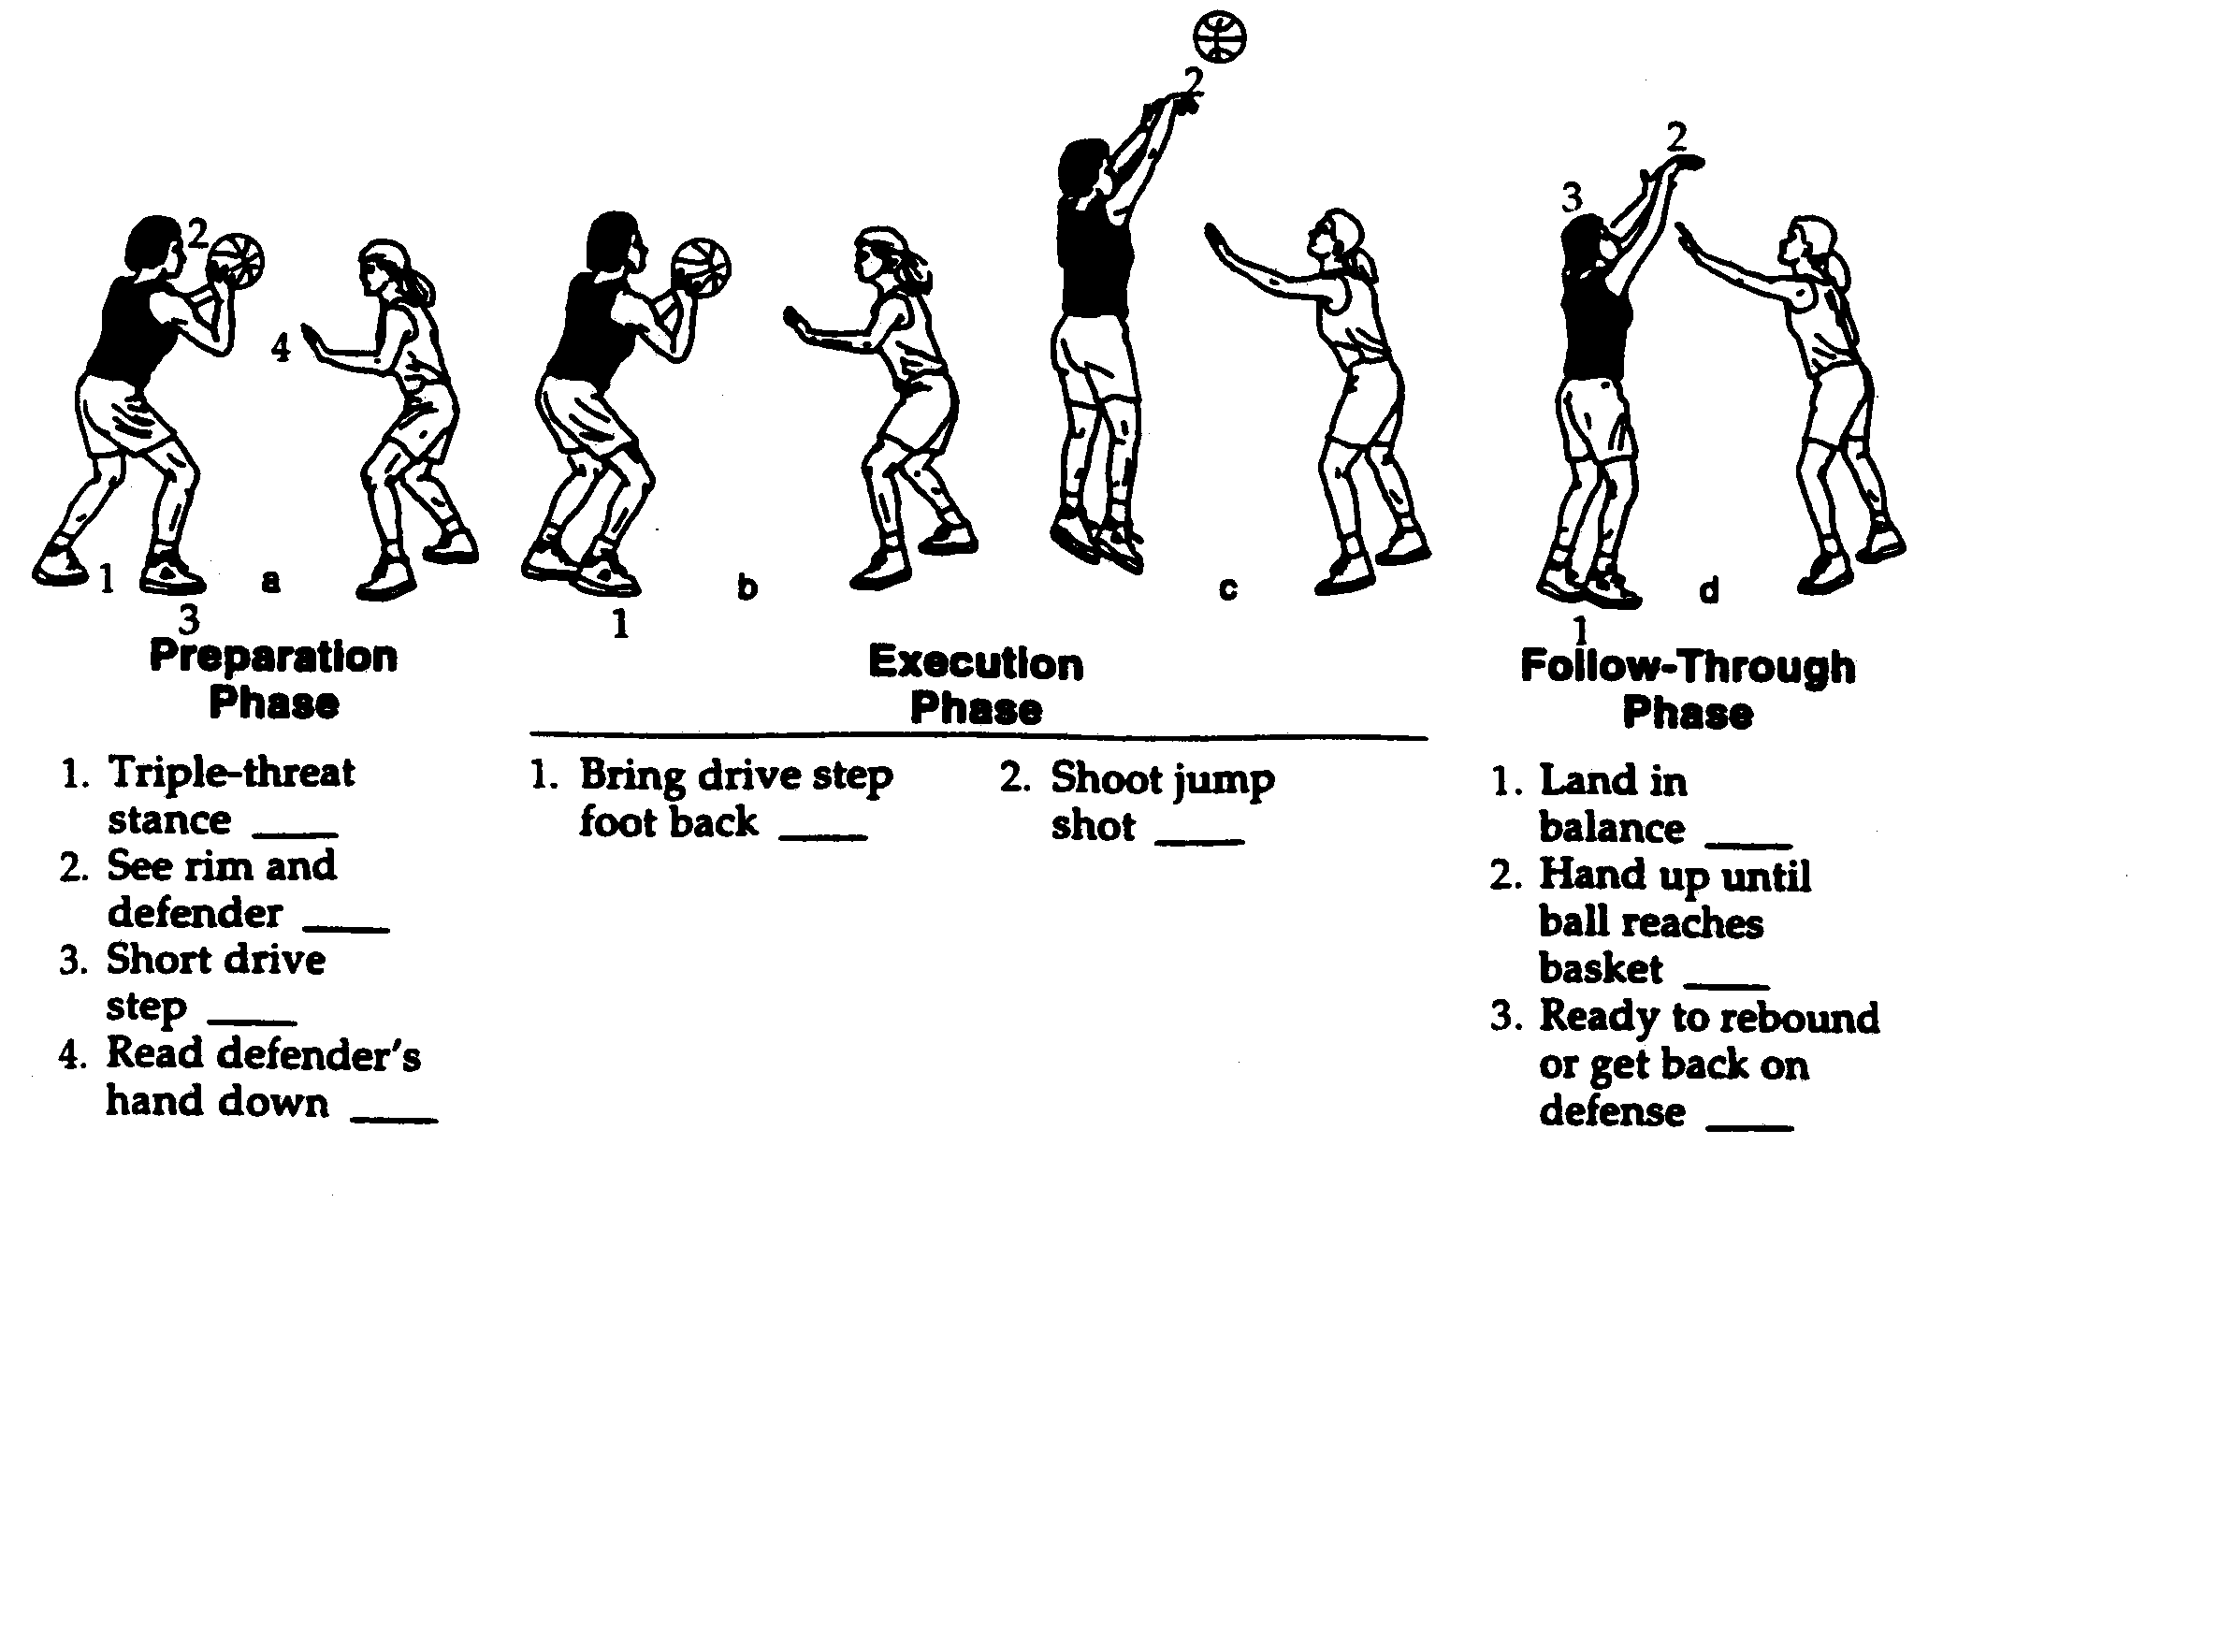

JAB STEP, STEP BACK JUMPSHOT
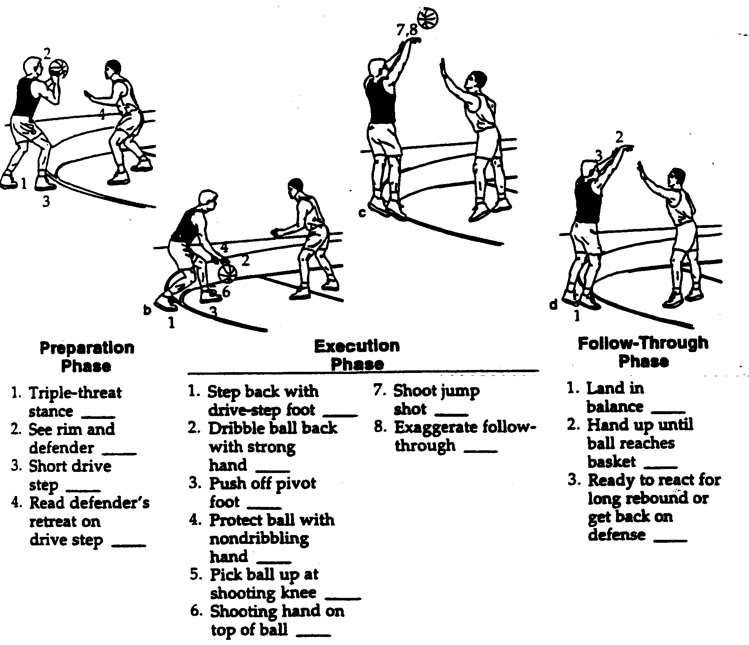
MOTION OFFENCE

Motion offence is basically an endless type of offence where certain rules are set by the coach that players have to follow until they can achieve an easy basket. Motion Offence is run against a zone defence this happen from a set formation such as a 1-2-2 or a 1-3-1 see diagram below are the most common.
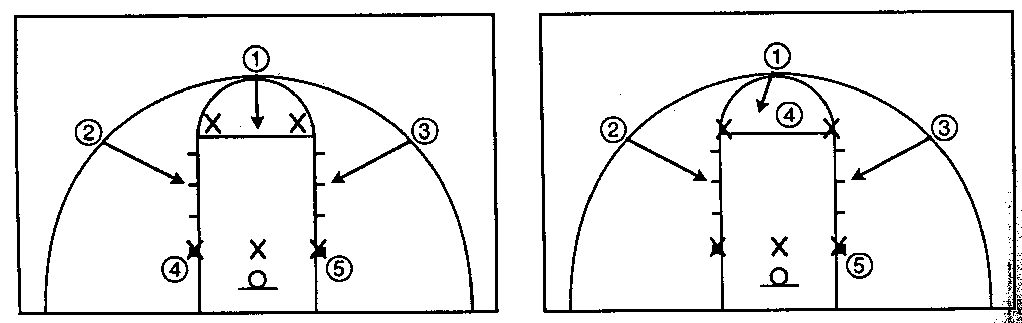
1-2-2 set 1-3-1 set

Within the following strategies attacking team adopts a 1-3-1 formation to combat the zone defence of the opposition and from the outset it also means that the offence has width and depth. The guard is positioned at the “point” (1), the forwards (2+3) are positioned on the free throw line extended outside the three point line, one centre (5) is in the low post area just outside the key with the remaining centre (4) just above the free throw line in line with the two forwards.

The key to breaking down a zone is to make the ball do the work whilst keeping the defence on their toes with people cutting through the zone.

Type 1 Pass and cut:

Player with ball must pass the ball then cut to the basket other players without the ball must move too keep good spacing fundamentals and court balance.

Developing the pass and cut

Aim of drill: to introduce the pass and cut to the basket.

Diagram description:

In diagrams 13-14, by using three passes, X1 completes three passes with his partner X2 who has possession after the third pass. X1 now cuts to the basket, receives a pass from X2 and shoots with a lay-up shot. Player X1 should not require a dribble.

Diagrams 15-16 explain the introduction of a defender to make it a 2v1. Following X2 out using passive defence at first the attacker X2 will have to use a fake to be able to pass the ball to X1. No dribbling is allowed.

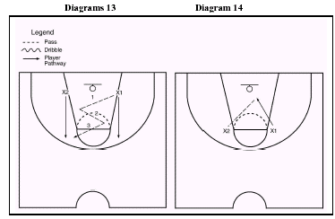
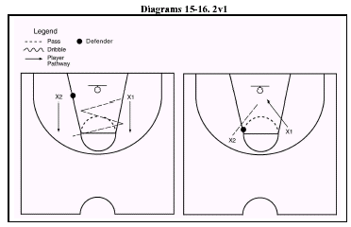
Diagram 15 – 16: key points

The 2v0 is an effective way to introduce the pass and cut to the basket. This is an important attacking move in basketball. From it you can learn about how both depth and mobility are important principles of play for both individual and team performance.

The player who is receiving the pass must present a target hand by signaling for the pass. The passer should pass ahead of the receiver so that this leads him/her to the basket. The player receiving the pass should try to catch the pass when his/her feet are in the air. This will mean that they can take two steps to the basket. If they are on the ground when they receive a pass they can only take one step. The person cutting to the basket to complete their lay-up should complete their lay-up shot by placing the ball just inside the ‘magic square’.

The next progression is 2v1 ‘live’. The defender follows X2 out but when the defender tries to stop X1 from scoring. Decision-making is being introduced. The student should look at the different options available to the offence. For example,

- X2 to X1 and lay-up.

- X2 to X1 – defender covers back therefore X1 to X2 and shoot or lay-up (no dribble).

- Defender stays in middle of key preventing X2’s pass to X1, therefore X2 must shoot the ball.

The key principle is that if you are being defended you pass the ball and move, i.e., basket-cut. If you are not being defended – shoot. You only move on to 2v2 when you have covered screening and driving.

Type 2 Pass, Screen and cut:

The player passing the ball must set a screen away from the ball. The player using the screen must read the defender and cut hard off the screen passing shoulder to shoulder with the screener.

Aim of drills: to introduce screening on the ball in a 2v0 cut to the basket.

Diagram description:

Using the three-pass start the passer X1 then sets a screen for X2. In diagram 18 X2 uses the screen, dribbles past and takes a lay-up shot. Diagram 19 shows the introduction of a defender who is screened by X1 who allows X2 to drive to the basket. Diagram 20 progresses to having 2v2.

DIAGRAMS 17 & 18
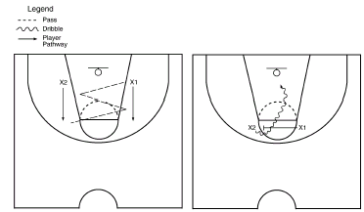
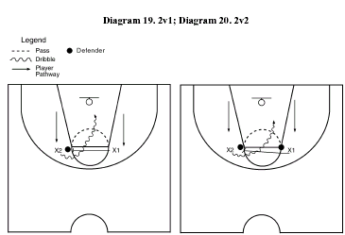

Diagrams 17–20: key points

X1 does not move to set the screen until X2 catches the ball. When X2 drives past X1 they should keep as close to X1 as possible. See Diagram 18.
In Diagram 19, a defender has been introduced who follows X2 out from the baseline.

After X1 has passed they set a screen on the defender’s shoulder to allow an uncontested drive to the basket.

In Diagram 20, ensure that the defenders in a 2v2 stay with the attacker they are marking. Do not allow them to switch.

Developing a screen and roll

Aim of drills: to introduce the screen and roll.

Diagram description:
After the third pass, X1 screens X2. X2 takes one or two dribbles. After the screen,

X1 reverse pivots on right foot and rolls to the basket. X2 bounce-passes to X1 who shoots a lay-up. This is shown in Diagram 21. Diagram 22 shows the introduction of a defender for 2v1.

In Diagram 23 the 2v2 game allows increased decision-making. Diagram 24 shows another option, the backdoor cut. This play gives player X1 increased options and at the same time is able to confuse the defender. Player X1 goes to screen, but only goes halfway, then pushes off their front foot and basket-cuts, signaling to receive a pass from player X2.

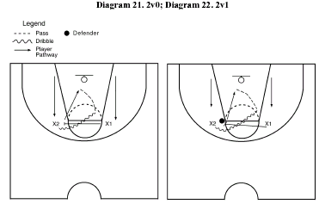

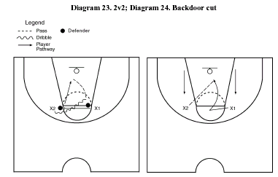

Physical Education: Basketball with Structures, Strategies & Composition – (Int 2/H) 39

Diagrams 21–24: key points

In Diagram 21, X2 should use a bounce pass because it is both easier to catch and it is harder to defend against.

In Diagram 22, X1 must try to set a screen on X2’s defender’s shoulder to take them out of the play. When they reverse pivot they will block the defender out and they will be on the ‘wrong’ side of the basket.
In Diagram 23, after X1’s screen, X2 can drive to the basket. If X1’s defender tries to stop them, they should pass to X1, who has rolled to the basket.
Diagram 24 is particularly effective when player X1’s defender is not guarding them too closely. This drill can be developed in practical contexts from 2v0 to 2v1 and on to 2v2. Following this comes a 2v2 ‘live’. At this stage further offensive plays can be developed and refined.

- the basket-cut
- the on-ball roll
- the screen and roll
- the backdoor cut.

The option selected is dependent on the defence response. The 2v2 game can be increased competitively by allowing the winners to stay on and a new defensive pair comes on to the court. When a team wins three consecutive games they come off.

Type 3 diamond:

The rule of the offence is when the ball gets passed low various cuts are made through the key and a rotation occurs. It can be split in to two parts with #’s 1,2 and 3 working together in a diamond formation (i) and 4 and 5 working the key and the baseline (ii).
After the pass is made low to 5 the following happens –(i) #2 cuts to the basket, facing the ball with their hands up, once under the basket they then carry on through to where 3 was positioned on the wing. As this happens 1 rotates from the point and takes up the wing position2 vacates and 3 rotates up to the point position. (ii) 5 has just received the pass and therefore adopts the triple threat position to see if there is a shooting or passing option on. After 2 cuts through the key 4 follows through after them looking for the pass in from the wing if they do not receive the pass they carry on through and out to the low post extended.

If they don’t have any options 5 then reverses the pass back to 1 then flashes high just in front of the free throw line (out with the 3 second area).
1 then rotates the ball back to 3 and the offence is then repeated.

To get a good shooting opportunity the ball must be rotated a number of times so the defence is moving about continuously. If a defender jumps out and is close to you or if you find that you are in a space (if you are #1,2 and 3) you drive past them to the basket – exploiting the zones weaknesses of the seams.

CHAPTER 4

DEFENSIVE STRATEGIES
KEY CONCEPT: Identification of Strengths and Weaknesses in Performance in terms of Formations and in terms of Tactical and design elements.

ROLES AND RESPONSIBILITIES IN DEFENCE

All players must be able to defend they should be quick and have good footwork so they can minimise the number of times that they are caught out of position.

Guard leads the defence makes picks up quickest player from the opposition and closes down outside shooters mainly plays perimeter outside defence and has to be able to rebound if required.

Forward plays perimeter or inside defence can be assigned to pickup best shooter must be a good rebounder.

Centre plays inside defence must be a strong defensive player and control the area under the basket. Must be a very strong rebounder.

MAN TO MAN DEFENCE

The object for this defence is that each defender is responsible for marking one player in the opposite team. Players would usually be matched for height, speed or skill. The defenders aim is to stay between his opponent and the basket and to put pressure on him when he receives the ball. The amount of pressure would depend on factors like, distance from the basket (i.e. pressure increases as the play gets closer to the basket) and the stage of the game (it may be necessary to apply increased pressure late in the game). Good individual defensive skills like footwork against dribble, rebounding are all important to ensure the defence doesn’t give away points.

As well as individual skills the ability to work and communicate as a unit will be invaluable in man to man defence. This is shown where players as well as marking their own player, also help cover in the event one of their teammates get beaten.

In this diagram, defender X1 puts pressure on player with the ball. They are in the BALL position. Players X2 and X4 who are one pass away from the ball stand one step away from their opponents in a position to cover X1.They are in the DENY position. In this way they can intercept any attacker beating X1 and also quickly put pressure on their player should they receive the ball. Players X3 and X5 are two passes away from the ball and so they can stand roughly two steps away from their opponents and are also in a position to help. They are in the HELP position. Through all this they must keep sight of their marker as well as the ball. In the event of a player getting beaten players would move towards the basket picking up the most dangerous players and initially leaving those furthest away. It is important to stop the player on the ball and mark those in the most dangerous positions. This will test the team’s communication and ability to play well together.

In the BALL position the defender should be putting maximum pressure on the ball carrier to slow them down, limit their space and time, prevent them from shooting passing or dribbling without fouling them and ultimately to try to steal the ball or force a turnover.

In the DENY position the defender is also working hard to deny space and time for their opponent. They are trying to prevent them form being a passing option for the ball carrier and close down any cut they make to receive passes and they will look to intercept passes made to their opponent.

In the HELP position the defender does not work as hard trying to close down the attacker they are assigned to mark. They tend to sag off their opponent to plug gaps in the centre of the key or fill in behind a teammate who has been dragged out wide. However they must be aware of where their opponent is at all times to pick them up if the move into a more threatening position or the ball is moved so that they are now one pass away.

Developing Man to Man Defence

Program of work to improve Man-to-Man Defence.

In order to improve your performance in man-to-man defence, there are a number of practices that you can do individually and as a team.

Structure, strategy and fundamentals are commonly used in different competitive individual and team games. These could include how to use space to your advantage when attacking and how to deny space when you are defending. (For example through applying pressure on attacking opponents.)

In using a chosen strategy you need to analyse strengths and weaknesses. In a team strategy it is useful to consider relevant principles of play, e.g. width, depth and mobility, which are all important in man-to-man defence. Another feature of man-to-man defence is that players are required to cooperate, support and effectively communicate with each other.

The following practices will all help develop your stance, positioning, footwork, communication and awareness.

Individual stance/footwork.

Chassis / shuffle footwork while moving backwards, zig zagging from side to side on the court. Keep your stance low and legs bent so that you can move quickly.

Individual Stance / Footwork

As above but with a partner dribbling a ball towards you. Keep your distance and position yourself accordingly so that they can’t drive past you but you are still keeping pressure on the ball carrier.

1v1 Game

Play 1 v 1 games, putting into the game the shuffling technique you have been practising. Keep your distance appropriate depending on the distance to the basket.

2 v 2 games.

As above however you now must consider another attacker and be aware of where your team-mate is. Communication is now vital so that if a player requires cover then you should let each other know. You should now position yourself so that you can see your marker and the ball at all times.

Shell Drill 1.
The coach ("C") passes to one of the three offensive players who stay put. There is no scoring, passing, attacking in this drill. This drill simply emphasizes how the defenders should position themselves in a man-to-man defence. In Diagram A, the coach passed to O2, so the X2 defender makes a good close-out and plays "on-ball" defence. The X1 defender sprints out into a "deny" position (one pass away from the ball), and assumes a position a little up the line and a step or two toward the ball-handler (to prevent not only the pass, but dribble-penetration). The X3 defender sprints out to "help-side" defence, dropping down into the lane (two passes away from the ball). The coach makes any corrections in the players alignment, and then the ball is passed back to the coach for the next three defenders in line. The current defenders become offence and the offensive players go to the back of the defensive lines.
Note in Diagram C, the pass goes to the point, and the X1 defender sprints out and make a good "close-out", while the two wing defenders sprint out into "deny" defence. Diagram D is the same as Diagram A, only to the opposite wing.

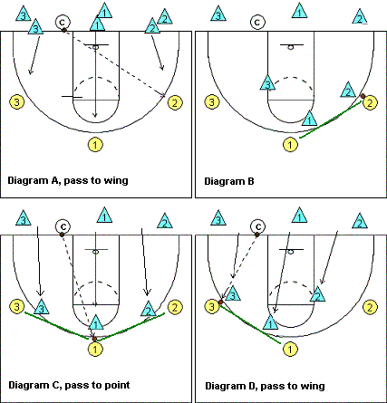

5v5 End Game

Using a full 5 a side team, work on organisation in and around the key area. This practice essentially works on communication, decision-making, organisation and offering cover.

The ball is passed around the 5 offensive players, with the defenders adjusting their positions accordingly. On the whistle, the ball carrier drives to the basket with his/her defender letting them go. Other players must then offer cover and try to cancel the threat.

Full 5 v 5 Games.

Put into practice all that has been done in a full court game. Players should be matched up according to height and defenders should try to focus remaining basket side of their marker with pressure being increased the closer they get to the basket.

Your weight should be on the balls of your feet (not your heels), and your feet should be about shoulder width apart. Keep your knees bent and your back straight. Keep your head up, eyes forward, arms out with your palms up and elbows bent a little. Watch the offensive player’s belly-button, especially if he/she is quick and hard to stay with. The offensive player can fake you with a head fake, eye fake, arm or shoulder fake, or a jab-step, but the belly-button will always go only in the direction that he/she is going.

When guarding your opponent, slide your feet sideways, using quick, short steps, and don't get your feet crossed. Don't hop. If you get beat in the open floor, don't just yell for help... turn and sprint after your opponent. Once you get in front of your man again, get back into your defensive stance.

Don't "reach-in". This causes you to lose your balance and defensive stance, and you become easy for the offensive player to get around. Reaching in also results in fouls and free throws for the opponent. Don't get into the bad habit of reaching-in and taking a swipe at the ball as the offensive player dribbles around you. Instead move your feet, hustle, stay with your man, and prevent him/her from getting to the basket by maintaining good on-ball defensive stance. If you get beat, sprint after the offensive player and beat him/her to a spot where you can once again resume your defensive stance.

REQUIREMENTS FOR MAN-TO-MAN

- Physical and mental toughness

- High level of Cardio-vascular endurance

- Focus – only have 5 fouls to play with

- Concentration and control – it can be very frustrating especially when fatigue is setting in and you can’t chase back you could vent your irritation by fouling when not needed to.

- Communication is vital – all players have to alert teammates to dangers e.g. screens etc.

ZONE DEFENCE

In Zone Defence the object is not to follow players around the court, but to cover an area of the court. When the ball or a player enters your “zone” it is your responsibility to deal with it. This defence requires discipline to hold your area and also good communication between the team as opponents move through the zones. The Zone Defence allows you to place players in key areas of the court, (tall players close to the basket, smaller, faster players on the outside) in this way you keep your strengths in the areas you need them. In most variations the tallest player is the “centre” and plays in the middle of the Zone, the next tallest “forwards” play to the side of the basket, and the smaller “guards” play at the top of the Key.

This diagram shows a 2-1-2 Zone Defensive line up. The circles mark out approximately the areas covered by each player. The players would move around their zone depending on the position of the ball. In this example the ball is on the right near the baseline. All the players have moved to the right of their zones and are in position to help. They will also be in a position to cover players near the ball. Those attackers further away are not an immediate danger and can be reached quickly if the play changes sides. All the players keep their arms up and make themselves as big as possible in an effort to cut down gaps in the zone. As the ball is passed into a zone the defender in that area moves quickly to put pressure on the ball and the other defenders adjust there positions in their own zone to offer help.

There are a number of variations in Zone Defence that can be used depending on your own strengths/weaknesses or those of your opponents. For example a 1-3-1 Zone is useful to counteract a Team with a good post player. A 2-2-1 or box and 1 is a good defence to counteract a good long range shooter while keeping the advantages of the zone.In all the formations of Zone Defence the principles are the same

1. Pressure the ball in your zone

2. Be big and close the gaps

3. Good communication
KEY CONCEPT: Problem solving and decision making within selected Structures, Strategies or Composition

Each of the two previous defensive strategies have their own strengths and weaknesses. It will be important to consider these when making decisions on which to use, along with your own and the oppositions make up.

Strengths Of Man- To-Man Defence

1) Simple to understand - you are given a player to mark and basically you have to stay between your allocated attacker and your basket wherever he goes.

2) This defence is very flexible - in that it can be effectively played full court, three quarter court, half court and in the back court areas.

3) This defence allows players to be well matched up - tall players can be matched up, fast players can be matched with fast players etc.

4) This defence allows maximum pressure to be applied - unlike zone defence, man-to-man defence allows you to contest every dribble, every pass, every inbound and every shot. Ultimately this pressure can lead to turn-overs and bad decision making.

5) Players tend to find man-to-man defence more exciting to play- unlike zone defence where there is restricted movement; man-to-man defence is far more active as your movements depends on the movements of the attackers wherever they are on court. This defence dictates that the game will be played at a much faster tempo and this keeps defenders both physically and mentally alert and players like this.

Weakness Of Man- To-Man Defence

1) Miss-matches can occur in man-to-man defence - if the opposition are unknown to you miss-matches may occur in terms of speed, strength and experience, which could be exploited by the opposition.

2) Defenders who are not well coached in the individual fundamentals of man-to-man defence can be exploited - upon receiving the ball good attackers square up and immediately "read the defence ", and if the defender is in a poor position the attacker will immediately take him on.

3) Because of its aggressive nature foul trouble can occur - because good man-to-man defence contests every pass, dribble and shot and because the pace of the game tends to be fast, defenders are often called for reaching and blocking fouls.

4) Players who are in trouble can be exploited - players who are in foul trouble, injured or tired are not able to defend effectively, and experienced players will exploit this ruthlessly by driving at the hampered defender.

5) Man-to-man defence is more physically demanding – for poorly conditioned players and small squads of players (5/6) man-to-man can be very tiring, and this can result in lapses in concentration and poor decision making.

6) Key players can be dragged out of position - the player dictates the defenders’ position he is marking, and for example, if an attacking centre deliberately stations their self high away from the basket, this drags the defensive centre away from the key rebounding area.

Strengths Of The Zone Defence

1) The defensive players positions and player movements are easily learned - players are given a specific area of floor to cover.

2) May be used with players at any level of skill or experience - inexperienced players are less likely to be exploited by experienced players, as the defender is covering an area of floor rather than a specific player.

3) Keeps tall defenders close to the basket - tall defenders tend, to cover the court areas close to the basket, these are key rebounding areas. Unlike man to man defence where the attackers position dictates the position of the defender.

4) Exploits poor outside shooting - because of the availability of plenty help side defence, there are few opportunities to drive against the zone therefore teams have to be good outside shooters, if not you are in for a long night!

5) Limits foul trouble - because driving strategies are cut to a minimum, zone defences tend not to foul much.

6) Can control the tempo of the game - because defensive player movement is less and driving strategies are less the game tends to be played at a slower pace than man to man.

7) Produces good positioning for the fast break - because the defenders will always know where they will be positioned following an attempted field goal, it is easier to run a structured fast break.

8)Reduces high % shots - because of the always available help side defence, high % lays up are not common against a zone defence.

Weaknesses 0f The Zone Defence

1) Zone defence is vulnerable in the seams of the zones - in the areas of court where one players defensive area overlaps his team-mates, there is often confusion as to whose job is it to cover that area.

2) Openings always exist - no matter what pattern the zone takes there is always going to be some area of court in the attacking end left open.

3) Easier to get open to receive the ball - attackers frequently do not have to work (e.g. do not have to use cuts) to get open to receive the ball. There is less pressure put on the attack.

4) Weak against good outside shooting - because a zone invites teams to shoot from the outside; if the shooters are in good form the zone will not be effective.

5) The zone can be impractical as it takes more time to set up - if players are slow to get back in defence there will be holes in the defence, which are vulnerable to the fast break or cutting attackers.

6) Easier to switch from man to man defence to zone than the reverse - you cannot play good zone defence until you have mastered the fundamentals of man to man. When an attacker enters your zone area you have to cover him man to man until he leaves your area, thus to play good zone defence you must be able to play man to man defence.

7) Can lead to poor defensive techniques - because there is less defensive movement in zone defence poor players can become lazy and lapse in concentration.

DEVELOPING THE 2-1-2 ZONE DEFENCE

Diagram 57 illustrates defensive alignment when the ball is in the middle of the court.

Diagram 58 highlights a breakdown drill for perimeter defence. The offending player X1 passes to X2. The defending player O2 advances mid-way towards X2. Defender O1 supports play by preventing the penetration dribble.

Diagram 59 illustrates the movements of defending players O3, O4 and O5 when the ball is played from the point of the key. Offensive player X1 initiates play either to X3 or X2, thus providing width in attack.

Diagram 60 illustrates a progression to a conditioned 5v5 game.
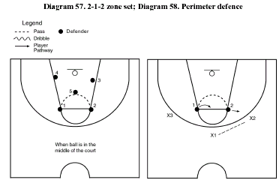

In Diagram 57, the defending players are aligned to defend an attack initiated from the middle of the floor. The defending players limit the attacking options by spreading their arms up and out, thus narrowing the angle of a pass or penetrating advance move. This could force the opposition to take outside shots.

In Diagram 58, the movement of the perimeter defensive players is highlighted in response to game demands. When the offensive player X1 selects to pass to X2, the defending player O2 advances towards X2 to stop the pass, O1 moves out to prohibit the penetration dribble towards the basket. Good communication and support play can force the offence to make hurried decisions.
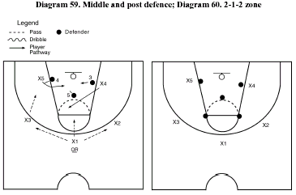

In Diagram 59, the movement of the centre (middle) and post players (forwards) is highlighted in response to game demands. The offensive players X1, X2 and X3 cannot shoot but try to create gaps in the defence by passing to X4 and X5 (who are allowed two dribbles). Players X4 and X5 should effectively use V-cut to vary direction and tempo of the attack. Creative use of screen and fake pass will help confuse the defence.

In Diagram 60, the formation of the defence is complete for a 5v5-conditioned game. The following rules should be applied. The offence must successfully pass five times before attempting to score.

2-1-2 Zone Defence Strengths

l) The defensive rebounding positions are excellent. The positions adopted by players 3, 4, and 5 forms the perfect rebounding triangle around the high percentage scoring area under the basket.

2) This defence exploits poor outside shooting. The 2: 1: 2 zone defence is so tight that it permits very few drives and inside shots, therefore teams are often reduced to outside shooting – and if you cannot consistently hit the outside shot your team will find it extremely difficult to score!

3) Fast break opportunities are increased. Because every player knows approximately where they will be at the time of an opposition shot, unlike man to man defence where you can be anywhere on court, it makes it easier to run a structured fast break. When a missed shot rebounds the 2: 1: 2 zone has the perfect rebounding triangle at the back, and players 1 and 2 who will be at front of the zone will be in perfect positions to receive an outlet pass to run the fast break.

4) The effectiveness of the 2: 1: 2 zone is increased on narrow courts. When the court is narrow there is no room down the sides to create an overload offence, or there is no room to pass to low pass and allow offensive rotations to take place via cutting players.

5) This defence does not allow defenders to be isolated in 1 v 1 situations.
Because of the areas of coverage defenders will always have team-mates in help side positions.

2-1-2 Zone Defence Weaknesses

1) This defence is ineffective against good outside shooters – because this defence defends an area not much bigger than the three-second area it is very vulnerable to good outside shooters from around eighteen feet from the basket.

2) This zone is vulnerable to fast breaking attacks – in common with all zone defences, slow returning defenders leave gaps in the zone coverage which are frequently missed by team-mates and are brutally punished by fast breaking attackers.

3) This defence can encourage lazy defence – because of the small area of floor covered by this defence, movement of the defensive players is limited and can lead to players becoming mentally and physically less aggressive and lazy.

4) This defence is very vulnerable on the seams down the sides of the defence – down either side an attacking player who penetrates the seam is going to draw in three defenders from the top, middle and bottom of the 2:1:2 zone leaving gaps in the defence for other attacker to exploit.

CHAPTER 5

PRINCIPLES OF PLAY
KEY CONCEPT: Identification of Strengths and Weaknesses in Performance in terms of Group and Team Principles

GROUP/TEAM PRINCIPLES OF PLAY

When designing and implementing a structure, strategy or tactic there are a number of principles of play that have to be taken into consideration to ensure that it is effective. We are going to look at these in terms of attack and defence.

PRINCIPLES OF ATTACK

As soon as a team/person is in possession, they are able to attack the opposition. The longer that possession is retained the more scoring opportunities can be created. The purpose of any attack is to create scoring opportunities and ultimately to actually score.

Width: This is the space between players across the pitch or court. When players create width in attack: they have more space and time in which to work and execute skills; it puts pressure on the defence by stretching them and creating holes in the defence called space; space provides more and easier one on one situations and gaps for players to run through and finally the defenders have to work much harder, as they have to cover more space.

Depth: This is the space between players along the length of the pitch or court. When players create depth in attack: they offer support options ahead of and behind the ball carrier, they have more space and time in which to work and execute skills; it puts pressure on the defence by stretching them and creating holes in the defence called space; space provides more and easier one on one situations and gaps for players to run through and finally the defenders have to work much harder, as they have to cover more space.

Support: This is the availability of options created by players of the ball. Players who are not in possession of the ball must be creating space and/or in a position to receive a pass at either side or in front and behind the ball carrier. When players support well in attack: there are numerous options available to ensure the attack continues, overload situations occur where attackers outnumber defenders, close marking defences can be broken down and uncertainty is created within the defence.

Penetration: This is the ability to break through and or get in behind a defence. This achieved by: players taking on the defenders and beating them in 1v1 situations though overload situations (2v1 for example) are best, fast counter attacks to catch the defence off guard, runs off the ball to get in behind the defence and passes played over the top of the defence for players to move onto.

Speed: This is the ability to create attacking opportunities through pace and speed of thought and action. This can be as an individual or an attacking unit. By using pace the defence has less time to organise and set up their structure and players can be caught out of position leading to gaps and overload situations.

Overload: This is creating situations where the attackers outnumber the defenders.

Mobility: This is movement on and off the ball it is the ability to change direction at pace move into space. An attack that is static is easy to defend, therefore players on and off the ball need to constantly be moving and changing direction to get free from the defenders, create space, offer support options and try to penetrate the defence.
Communication: This is required to make players aware of the attacking tactic; aware of support options, when and where they are in space etc. It can be verbal (a shout) or a visual (a hand signal)

Organisation: Players have specific roles and responsibilities (we will talk about this later). There are set plays to organise, the attacking formation and the tactics in open play.

Balance: Players must be spread round the key not all in one area of the attacking zone.

Look at the 1-3-1 attacking zone formation and how it covers these principles.

Player 1 - Point guard, teams play maker takes the ball up court and initiates plays. Usually small fast player good dribbler

Player 2 - High Post player, Build moves and screens throw him. Usually tallest player able to turn and jump shot as well as rebound.

Players - 3/4 Attackers, usually good shooters, they are also looking to penetrate the zone.

Player 5 - Low post or Corner player, 2nd tallest plays along the base line good shooter /rebounder.
Often moves to the “strong “side, (side of court with the ball on it.)

Arranged like this we have DEPTH up and down the court with player 1 playing “deep” outside the key, and also player 5 on the base line. It would be easier for the defence to compress the attack to cut down space, so by giving the team DEPTH you are helping to open up more space and spread the defence.

This formation also gives us WIDTH with forwards 3 and 4 covering either side and while they will often swap the team will always look to keep someone on the “weak” or “blind” side of the attack to give WIDTH. Again this will spread the defence and they will always have to be aware of players behind them.

Player 5 helps give the team MOBILITY as he moves from side to side usually playing on the “strong” side of the attack. Although the players have set positions they will often move and change around and the formation will keep its MOBILITY if players move to fill gaps. For example if 3 moves across 4 will often move across to balance the team; if one cuts to the basket 3or4 could move to fill his space.

PENETRATION is another principle of attack as without it the team may have possession but will be unable to score. (Remember teams have 30secs to take a shot.)

PRINCIPLES OF DEFENCE

As soon as a team/individual loses possession they are in defence. When in defence the objective is to stop and break down the opposition attack and regain possession.

Delay: This is the first priority slow down/delay the attack so the defence can get organised and consolidate their position. This can be done by reducing the time and space an attacker has you can force them to slow down: By forcing or channelling the player away form the danger areas or into an area that is well defended is difficult to attack from or has limited options: By hustling and jockeying the attacker without diving in an committing yourself.

Marking: This is ability of a player to stick with and close down the space and time available for the opposition this can be done when their assigned attacker is in possession or not depending on the type of defence being played. The marker may not have the responsibility for a specific player but rather an area of the court or pitch (zone) and is responsible for marking whichever player enters the zone.

Width: This is the space between players across the pitch or court. In defence it is important that there is a spread across the area so as to cover attacks through the middle or the wide areas.

Depth: This is the space between players along the length of the pitch or court. The defenders should never be in a flat line across the pitch or court. A defender must be able to move forward to close down the ball carrier. Depth is also important behind as well. The defensive formation must have an initial line of defence then at least 1 other line of defence to provide cover in behind. This prevents the initial line being by passed with a ball over the top and provides cover if the initial line is breached.

Balance: It is vital to maintain a balanced defence. The defence has to have a blend of width and depth and players should not all be drawn towards the ball the defence needs to maintain its shape. By ensuring this, the defence can cover wide attacks and prevent the attack exposing gaps when they switch the point of attack.

Communication: This is required to make players aware of the type of defence; aware of marking responsibilities, calling for help etc. It can be verbal (a shout) or a visual (a hand signal)

Organisation: Players have specific roles and responsibilities (we will talk about this later). There are set marking responsibilities, the defensive formation and defending set pieces.

DEPTH is particularly important in offering cover so that if one line of defence is beaten there are others to take their place. For example in Man-to Man where players offer help to the player marking the ball carrier.

WIDTH is also important to cover switches of play to the weak side of an attack. If all the defence ends up on one side of the court then you will be open to attackers on the blind or weak side.

CHAPTER 6

ADAPTING STRATEGIES

KEY CONCEPT: Problem solving and decision making within selected Structures, Strategies or Composition

ADAPTING STRATEGIES

After a game is over teams will often analyse their performance and alter their strategy as a result. But often during game, circumstances may dictate that a team must change the way they are playing, often as a result of the opposition’s tactics. It is therefore a good idea to have alternative strategies available in case you need to change. In Basketball teams have the advantage of time outs to make adjustments or changes to the team’s strategy. In other games the coach may have to wait until half time or try to shout instructions from the side.

The following are 2 situations that could occur in Basketball and the changes the team could make to solve the problem.

PROBLEM 1. - Playing a 2/3 Zone defence formation you are losing a lot of long range shots to one player in the other team. Apart from that the Zone is working well and the other team are finding it hard to penetrate your defence.

SOLUTION - You could change your defensive system to a “Box and 1” formation. In this formation you keep 4 players in a box shaped Zone, plus one player who is going to go Man to Man against the good shooter on the other team. In this way you keep the advantage of the Zone, which the other team are finding it hard against, and you are also able to put more pressure on the player who has been scoring so many points. The other alternative could have been to go straight Man to Man but this would have lost the effective part of your defence. You will need to keep evaluating how the new defence is working and if there are problems it could be that Man for Man is your next alternative.

PROBLEM 2. - Playing a half court Man To Man defence you are 4 points down and have to score at least twice to win or take the game into extra time.

SOLUTION - You call a time out and change the strategy to a whole court press. This is an aggressive Man to man defence all over the court. The aim is to win the ball back as quickly as possible by pressurising the other team into making a mistake and looking for an interception. Straight from the restart you pressure the opposition and if you get one basket back you keep the pressure on as they try to get the ball back into play. This is a high risk strategy as played over a long time it will lose you points, but in the last minute you can’t afford to sit back and you need to change the pattern of play quickly.

The need to change or adapt current strategy will depend on the following types of offensive and defensive considerations:

- the strategy is working or not
- adjusting defence rhythm to upset the offence
- to catch up or to exert even more pressure
- whether the individual / team is in foul trouble
- to suit individuals in key positions who can affect an advantage
- to pressurise key players in the opposition
- the physical demand of the adopted strategy
- the time is running out
- you are being beaten
- you are winning.

Points to consider

The players must be able to respond to changing situations by adapting team strategies. To be able to adapt, the team must:

- know the alternatives
- have practiced playing against varying offensive/defensive structures
- have practiced changing from one strategy to another
- all be able to react on court.

For example: in end games, the team initially plays 2-1-2-zone defence v 1-3-1 offence. Offences could then alternate between man-to-man defence to zone defence. The offence consequently has to adapt their strategy. This requires good decision-making, communication and co-operation by all team members.

This is the reason why we have looked to develop a number of fast break alternatives. However there are also times when we will not be ale to run a fast break or it has become to predictable so the next stage is to look at alternative strategies to the fast break.

CHAPTER 7

METHODS OF ANALYSING STRATEGIES

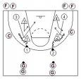
KEY CONCEPT: Problem solving and decision making within selected Structures, Strategies or Composition

METHODS OF GATHERING DATA AND WHY THEY ARE APPROPRIATE

How do you decide which strategy best suits your team. Look at methods of collecting information/data.

When collecting information on how well your strategy is working you must make sure that the information you collect is; VALID in that it tells you relevant information; that it is ACCURATE and well presented so you can make correct decisions; and that it is RELIABLE.

Thoughts and feelings The simplest method of gathering data within the activity is through the performers thoughts, feelings and reflections. This is useful as a starting point and can indicate where weaknesses may lie. It is particularly useful for assessing the mental aspects. However it is not totally reliable as it could be biased and is an opinion of the performer not necessarily an actual fact. To gather quality data more scientific procedures need to be adopted.

Coach’s opinions This tends to be more accurate as the coach has an expert opinion, which tends to be objective. The coach is comparing your performance to his/her criteria of a good performance drawn from their own experience. Yet again this is an opinion and not a fact and it is governed by the coaches level of experience but can be a good starting point from which to gather more in depth data.

Video this is a particularly good method of gathering data in any activity but is especially good for team games or fast moving games where something could be missed. Video is particularly useful in these situations as it can be paused or played in slow motion or rewound and replayed as often as the viewer requires. This allows a very accurate and detailed observation to be carried out. Video provides the performer with visual evidence of their performance. Video is also a permanent record that can be compared to a later video to see if there are any changes to the performance after a fitness training programme of improvement has been carried out. However video assessment is only as effective as the criteria that are used to assess it, simply filming your performance and watching it will be of limited value. The most common and easiest way is to analyse the video in relation to criteria on an observation schedule or comparing to a video of a model performance.

Observation Schedule. This is a sheet, which is made up before participation in the activity. It can take various formats from a simple tally sheet e.g. an observation schedule can be tailored to meet the requirements of the activity and the data to be collected. It can gather a lot of general data or much more focussed specific data depending on the criteria used. In order for an observation schedule to be effective there needs to be some time spent considering its design and research to ensure that the criteria it contains are relevant and actually measure what it is intended to. The Schedule is only as effective as the person who completes it. This means that to complete a schedule the observer requires an understanding of the activity. The more complex and detailed the data required the more expertise the observer should have. For simple observation schedules it would be appropriate to use a classmate but for more in depth analysis a teacher or coach would be better. The observation schedule can be completed whilst watching the activity or afterwards from a video of the activity. An observation schedule is an appropriate method as it provides a permanent record, it can identify strengths and weaknesses, it has specific criteria to compare your performance to, it can be made specific to your needs, it is simple to use, can allow a before and after training comparison to check for improvements.

Games Analysis Sheet - Taking a feature of the game and examining it under game conditions will also give you information on how well your strategy is working. This could be done from a live game or even better from a video where you could slow down or stop the action.

For example a court diagram showing where points had been scored against you in a game and by which players would point out weak areas of the court and in a man to man defence weakness in your team. The same information in attack would show your strong areas and shooters and allow you to focus your attacks on these. Any aspect of the game could be taken and subjected to this type of statistical analysis. On their own however raw statistics could be misleading so video back up or feedback from some one who saw the game is a useful safeguard.

In this example we are looking at shots taken against our 2-1-2 Zone.

We can see we are generally good at restricting the other team to shots outside the key. However we have lost 2 lay ups close in our back right area. Looking closely at the video we were able to highlight one of our players who was being drawn too far out of position creating the gap for these shots. We would work on this players positioning in practice.

We can also see that while we are restricting them to long shots, player 6 in their team is scoring too many points. We would need to react to this by changing to a different strategy, perhaps a combination defence of box and 1.
X – shots taken
O – shots scored

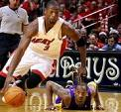

ANALYSING THE FAST BREAK

Watch the game or video action to help you to analyse how effective your team is in using a fast-break strategy. You should be aware of different tactics previously rehearsed during practice sessions. Use the key at the bottom of this sheet to help you to record your findings.

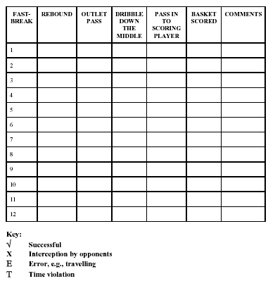
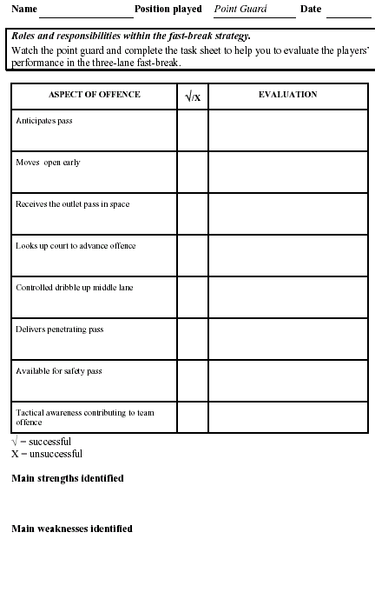
DETECTING AND CORRECTING ERRORS IN THE FAST BREAK

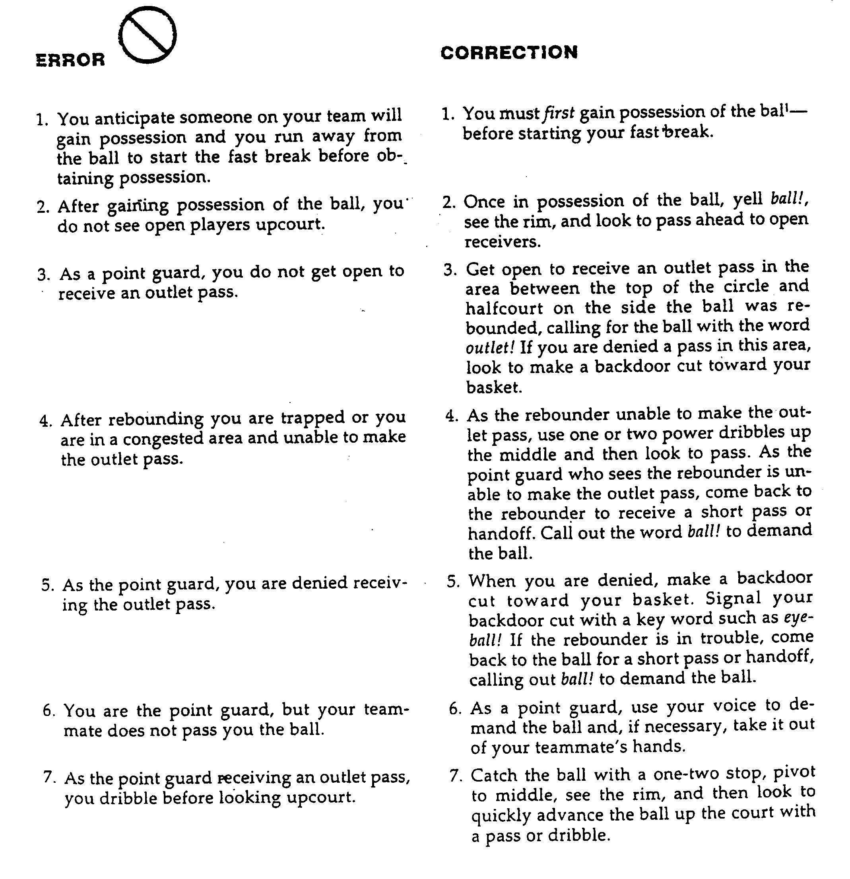
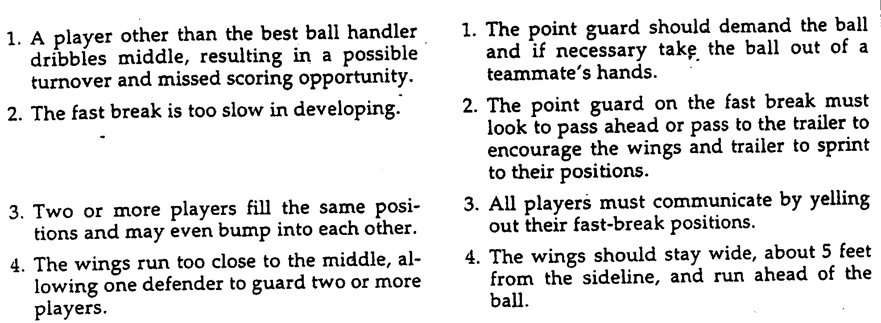
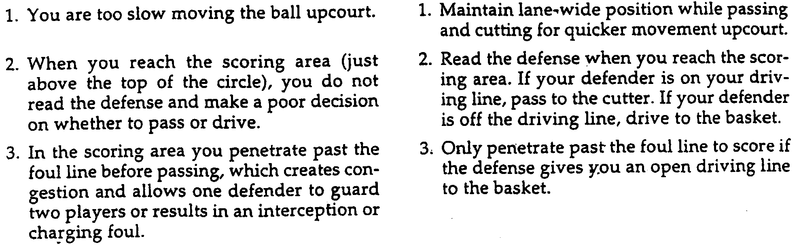
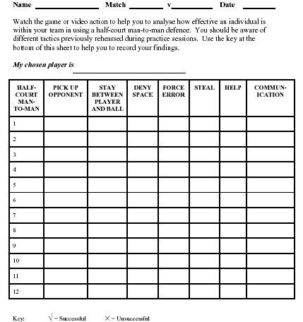

ANALYSING THE 2-1-2 ZONE DEFENCE

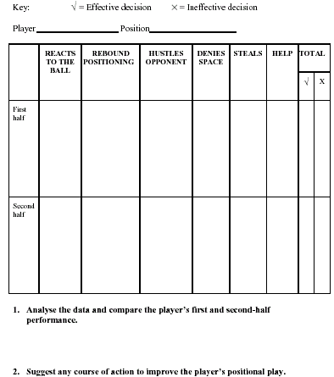

CHAPTER 8

Football

Structures & Strategies

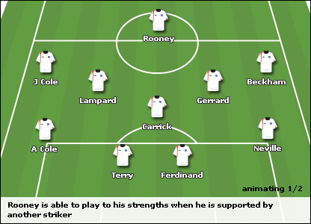
PRINCIPLES OF PLAY

ATTACK

Penetration - when attackers find themselves in space in a threatening position to the opposition goal – either central or in wide areas.

- Counter attack at speed – a team always at its weakness when they have just launched an unsuccessful attack – short quick passes to penetrate opposition before they can regroup and organise themselves – long accurate passes into gaps.
- Getting in behind a defence – dribbling – taking men players on and eliminating defenders – passing long and short between defenders – shouting – one two’s – overlaps

Mobility – creating space between or behind defenders through cross field or diagonal runs – movement off the ball, preferably on the blind side of defenders.

Depth – Creating space both forwards and backwards – creating opportunities for passes – pushing up onto the last defender – coming off the defender quick to release quick passes between defenders and midfielders.

Width – Stretching defences the width of the field – helps create space between defenders – better opportunities for retaining possession.

Overload – Creating situations where the attackers outnumber the defenders – overlapping full back – dribbling eliminating defenders and passing off – committing defenders to pass.

Unity – When in possession the whole team is concerned with supporting the attack

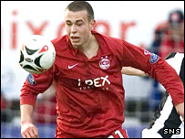

DEFENCE

Delay – Don’t commit yourself into tackle – slow down attackers – enables team to regroup and organise itself – closing down scoring opportunities – look for opportunities to regain possession – force players onto weak side.

Balance – Defenders must ‘kill’ space for the opposition – mark areas – pick up when opponents enter that area – cover defenders who are under pressure with man in possession – don’t get to far apart.

Depth – Fatal to be caught ‘square’ (where one pass beats all the defenders), reactive system to 20-25 yards from goal with space man marking depth and cover – could be centre back peeling off or full back picking round – defending on opposition strategy.

Overload – situation where defenders may ‘double team’ player in possession – close down space around them – don’t give them time to think out a pass – leave hardest pass open to them with opportunities to intercept.

Concentration & Communication – The ability to read situations – talk to one another about change of organisation – react to change in the defensive setup – anticipation of opposition movements – make decisions at the right time.

Unity – think defensively when opposition have the ball.

